**Inter-Service Club Council of the City of Fairfax**

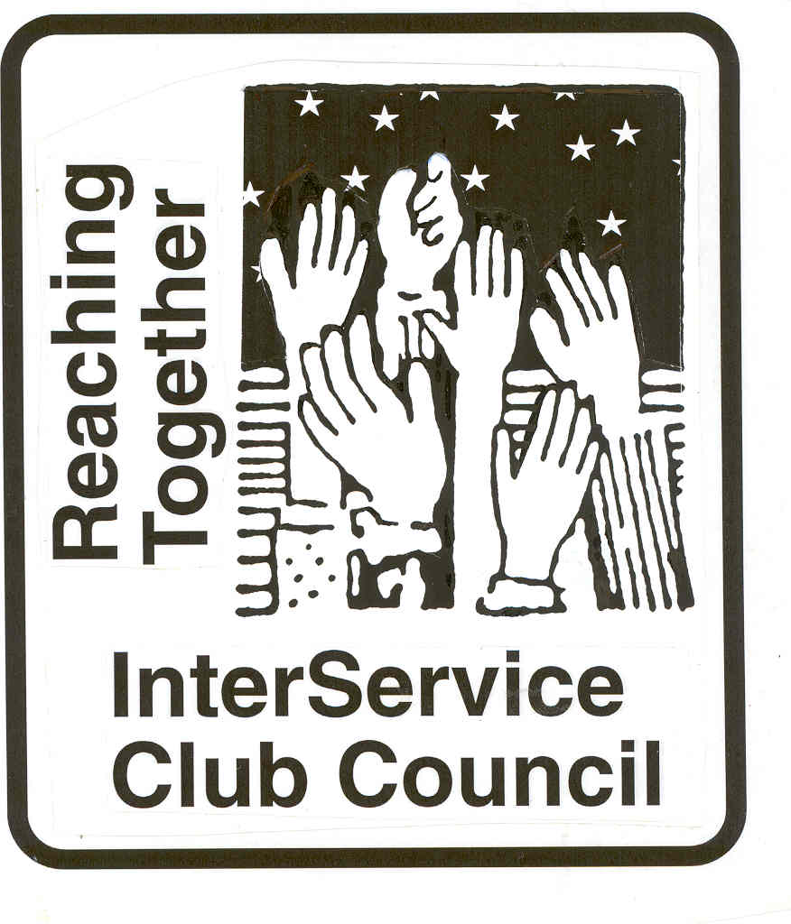

**iscc-fairfaxva.org**

Volume 47, Number 3 1 December 2021



***Next Meeting***:

Wednesday, 5 January 2022

12:00 PM

???

**ISCC Minutes**

President Leightley called the meeting to order at 12:03 PM. Sixteen members representing 17 organizations were present. Vice President Grimsley gave the invocation and all recited the Pledge of Allegiance.

Claudia Morcelo and Trinkot Troy from the Optimists, and Rose Robinson from Service Source were guests.

OFFICER REPORTS

Minutes of the October meeting were approved as provided.

Vice President Grimsley had nothing to report.

Treasurer Lauther provided an update on ISCC dues All but 6 clubs have paid. Treasurers report was approved as provided.

Immediate Past President Larson had nothing to report.

President Leightley had nothing to report/

Rose Robinson from Service Source spoke about their programs and challenges.

Clubs presented their reports.

The meeting was adjourned at 1:18 PM

***City of Fairfax***

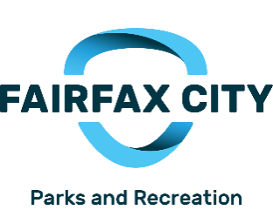

|  |  |
| --- | --- |
|  | Old Town Square, 10415 North Street  Holiday Festivities - 12pm - 6pm, Come listen to live holiday  music, crafts and enjoy s'mores and hot cider at Old Town  Square Tree Lighting Ceremony - Come enjoy caroling and  lighting of the Christmas at Old Town Square at 5:30pm.  No charge. For more information, call 703.385.7858 or visit [www.fairfaxva.gov/specialevents](http://www.fairfaxva.gov/specialevents)  Lunch with Santa  Sponsored by Fair City Mall  December 11, 2021  Old Town Hall, 3999 University Drive  Children ages 10 and under can enjoy lunch with Santa at the  Old Town Hall. There will be three lunch seatings will be  offered - 11am, 12pm and 1pm. Tickets ($8 per child) will go  on sale November 1 at the Parks & Recreation office at City Hall,  Green Acres Center, and Sherwood Community Center or online.  Limit of 10 tickets per person.  Holiday Market  Old Town Square, 10415 North Street  Join us for the 5th Annual City of Fairfax Holiday Market in  Old Town Square. Come and shop at the market of artisans  as you enjoy Old Town Square in the heart of Historic Downtown  Fairfax covered in holiday lights. The festival will include live  holiday music, hot drinks, and gourmet treats and more!  The Holiday Market will be open the first 2 weekends of  December on Friday, Saturday, and Sunday. Artisans will  vary each weekend.  Market Dates  Weekend 1: December 4,5, and 6  Weekend 2: December 10,11 and 12 |

**Mitzi Taylor** [**mitzi.taylor@fairfaxva.gov**](mailto:mitzi.taylor@fairfaxva.gov)**;**

***Chocolate Lovers Festival Committee (CLFC)***.. ***Chocolate Lovers Festival Committee (CLFC)***

Mitzi Taylor [Mitzi.taylor@fairfaxva.gov](mailto:Mitzi.taylor@fairfaxva.gov)

***Independence Day Celebration Committee (IDCC)***.  ***Independence Day Celebration Committee (IDCC***

Brenda Brichant [bbrichnat@gamil.com](mailto:bbrichnat@gamil.com)

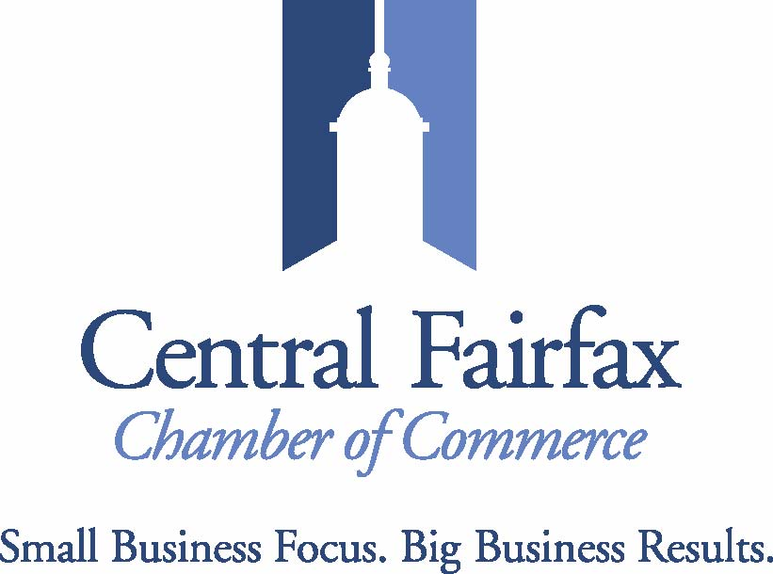

The Central Fairfax Chamber of Commerce held a successful Small Business Saturday Welcome Station on Saturday, November 27 in partnership with the Old Town Fairfax Business Association and the City's Economic Development Authority. Nearly 100 people came through to collect their Elf on the Shelf Scavanger Hunt Card, visit Santa, write letters to Santa, and enjoy hot chocolate, coffee and treats from Cameron's Coffee and Chocolates.

In December, we are co-sponsoring a Virtual Health and Care Job Fair with the Fairfax County Long Term Care Coordinating Council, Fairfax County Economic Development Authority's Talent Initiatives, and the Fairfax County Department of Family Services on Wednesday, December 8 from 1pm - 4pm. There are more than 30 employers participating as well as information on training for upskilling for better paying jobs in the Healthcare industry.  Please visit the Events page on our website - [www.cfcc.org](http://www.cfcc.org) - for more information.

Looking to 2022, our Office is relocating to Willowood Plaza in advance of a larger MEC and Fairfax City Economic Development Office relocation to the same area. We are once again sponsoring Restaurant Week - two weeks in 2022!

You are always invited to attend our events! Please join us on Wednesday,  December 8 at 5:30pm for our Holiday Networking Mixer at the Auld Shebeen. In addition, we have a joint Women Mean Business and Young Professionals "Holiday Shenanigans!" Holiday Mixer on Wednesday, December 15 at 5:30pm  Epicure Cafe.

Have a wonderful holiday season!

**Jennifer Rose:** [**Jennifer@cfcc.org**](mailto:Jennifer@cfcc.org)

**Civitan Club of Fairfax**

In November, members of Fairfax Civitan Club purchased a considerable amount of non-perishable foods and delivered the food to the Food for Others organization for distribution to low-income seniors and other needy folks. In December, our project is to gather “toys for tots,” and Fairfax Civitans seem to particularly enjoy doing so. Our January drive is to collect blankets for special needs children in a live-in school in Africa. Our pile of warm blankets is already growing.

Over the winter holidays we continue with our fund-raising activities, especially the sale of White House Christmas ornaments. We did make a little money in a Saturday in November at the Arlington garage sale. It was the only garage sale in 2021, compared to the eight sales a year pre-pandemic. Our variety show took place via zoom.

We did not have a regular Fairfax Civitan Club meeting in December. We did offer two fun events for Club members. Right after Thanksgiving, on a Sunday afternoon, some of us met at Eavesdrop brewery to enjoy some food, drinks, and fellowship. In December we are planning a zoom gathering where members and friends can play bingo and other games.

**David Hartmann:**[**chartmann@cox.net**](mailto:chartmann@cox.net)

**Downtown Fairfax Coalition**

**Jim Wyckoff, Jr.: jcwyckoffjr@aol.com**

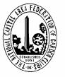 **FAIRFAX FERNS GARDEN CLUB**

meet Dec 13 for the Fairfax Ferns will decorate Old Town Hall on Monday November 29 at 5:30pm, The Ferns will next holiday party .

**Kathy Hoffman:** [Kathryn.j.hoffman@gmail.com](mailto:Kathryn.j.hoffman@gmail.com)

**Fairfax VA Harley**

**Owners Group**

Our Chapter continued the tradition of sharing a Thanksgiving dinner with all the trimmings to 135 of our fellow citizens, who happen to be homeless, at The Lamb Center on November 24th. Twenty Chapter volunteers stepped up to help prepare a tremendous and healthy feast to share. They also helped with the serving and the warmth of good food and fellowship was abundant. There were plenty of leftovers to serve to guests on Friday and Saturday. Several folks added some cash that will be donated as well. It was a sunny day outside, but inside it was especially sunny. We are thankful indeed for this association.

We will busy on December 4th participating in Adopt-a-Spot with Patriot H-D to keep our community looking spic and span.

Christmas Stockings are being filled to support the Salvation Army’s Christmas Program. We are not sure who has the most fun, those that fill them or the families who empty them during the holidays. The Christmas stockings are now starting to return filled with gifts that will bring joy to parents and children who will likely not receive much else. Cash donations will also help fill the gift lists. The holiday spirit is in the air and we are grateful for this opportunity to share.

On December 11th a team of Chapter elves will be busy at Santa’s Workshop at the Salvation Army assembling bikes and other toys and putting together gift boxes for less fortunate families. On December 16 and 17, we will be on hand to help deliver the Christmas packages to the families qualified by the Salvation Army. More great times.

We appreciate the blessings of being involved in our community during the past year. We look forward to new riding activities in 2022. Safety training and community support activities will be similar to 2021 and solid components of our 2022 Program.

Our Chapter membership includes 320 members who are a diverse and energetic group. The Chapter publishes a monthly newsletter and maintains its own web page at [www.fairfaxhog.com](http://www.fairfaxhog.com).

We wish you all a Merry Christmas, Happy Holidays and a Healthy and Prosperous New Year.

**Larry** **Larson: larry.d.larson@verizon.net**

**Fairfax City**

**Regional Library**

**City oFairfaxLibrary**

**10360 North Street**

**Fairfax, VA 22030**

703-293-6227 | TTY: 711

Sun.: 1 p.m. - 5 p.m.

Mon. - Thurs.: 10 a.m. - 9 p.m.

Fri.: 10 a.m. - 6 p.m.

Sat.: 10 a.m. – 5 p.m.

The City of Fairfax Regional Library offers a wide range of events for all ages, including children’s programs, ESL Conversation groups and tutoring, technology help, book discussions, genealogy and local history programs, and much more.

<http://www.fairfaxcounty.gov/library/events/>

The Friends of the Fairfax City Library continue to work towards our April sale. Donations are picking up so that we need more volunteers. We are reaching out to the community via local newskletters,. We sort books every Tuesday from 10:00 a.m. till noon and then go for coffee and/or light lunch. We also need people to volunteer to empty the donation bins, We have funded children's programs through May.

.**Katie Clary**: [kvclary@mindspring.com](mailto:kvclary@mindspring.com)

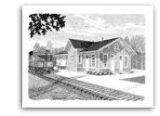

**Friends of**

**Fairfax Station**

**Create a Holiday Ornament at the Fairfax Station Railroad Museum**

**Join your friends at the Fairfax Station Railroad Museum for the final event of 2021 on Sunday, December 19 from 1-4 p.m.  Create a holiday ornament or package decoration of your very own.    Supply fees are included with admission.  One ornament or decoration per person while supplies last. The Museum is located at 11200 Fairfax Station Road in Fairfax Station, VA.** [**www.fairfax-station.org,**](http://www.fairfax-station.org,)[**www.Facebook.com/FFXSRR,**](http://www.Facebook.com/FFXSRR,) **703-425-9225.  Admission:  Museum members and ages 4 and under, free; ages 5-12, $3; ages 13 and older, $5, special events, $6; seniors and military (active and retired) $4.**

**Pete Conklin:** [**conklinps@aol.com**](mailto:conklinps@aol.com)

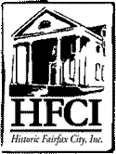

The December **meeting of HFCI’s Board will be held December at 7PM. It will be the Holiday Annual party held at John Keith’s home. Officers for year 2022 will be elected**

**There are 2 HFCI Board positions available. If you are interested in serving, please call the nominating Chair.**

If you are a member of a club or organization and would like to know about what HFCI represents, ask for a 20 minute presentation. Call Al Leightley at 703 273 2089.

As a member of HFCI, not only are you supporting history, you receive a discount on

products in our gift shop and you also receive a quartley newsletter which features a local historical story each issue. Please pick up a brochure and send in your application.

Are you interested in being a volunteer or docent for historic sites? Call 703 385 8415 and find out more about it. Would you like to be remembered forever as a citizen of Fairfax? Buy a brick with your name on it for $100. The bricks are placed in front of the Fairfax Museum.

Share your story with HFCI, s ORAL HISTORY PROJECT. If you or if you know someone who has lived in the City for most of their life; our oral history program shares information about the past!

The Fairfax Museum and the Blenheim Center are open for visitors. Docents at the sites are back and tours are being held. Rentals for the space is open. Masks are mandatory

indoors.

THE WHITE HOUSE ORNAMENTS ARE IN: HFCI will be selling them in at the Museum and Blenheim. The ornaments are $22.

**Programs at the Fairfax Museum and Blenheim:**

**MUSEUM: Programs are at 2PM every other Sunday**

**Fairfax Museum and Visitor Center 10209 Main Street, 703 385 8414**

**Sunday, December 12, 2 – 4 p.m. – Fairfax Museum and Visitor Center**

**“Sounds of the Season and Gift Shop Specials”**

Enjoy festive holiday music while you shop for gifts from stoneware mugs and pitchers, adult and children’s books, candles, White House and Virginia ornaments, and more.

**BLENHEIM**: **Civil War Interpretive Center**

**3610 Old Lee Highway**

**Sunday, December 5, 12 -4 p.m. – Historic Blenheim –**

**“Christmas in Camp and Making Do at Home”**

Learn how soldiers and their loved ones at home celebrated Christmas during the Civil War. Meet the living history presenters around the campfire, practice drilling techniques, and join in with a cease-fire exchange of gifts.  Hear the voices of soldiers and civilians recall wartime holidays in a virtual program recorded in 2020.  Take home packages with materials and instructions to create handmade Victorian ornaments will be available.  Scouts and other groups must reserve a time for drills and house tours by calling 703-591-6728 or email [andrea.loewenwarter@fairfaxva.gov](mailto:andrea.loewenwarter@fairfaxva.gov)

**EXHIBITS**

**Fairfax Museum and Visitors Center**

October thru December:”The Long Tradition of Virginia Canneries**” A Traveling exhibit from the Blue Ridge Institute in Ferrum.** Stories from cannery workers, production images and displays of canning equipment.

**Website: historicfairfax.org**

**Hildie Carney:** [**hilcarn31@aol.com**](mailto:hilcarn31@aol.com)

**Kiwanis International**

**Kiwanis Club**

**of Fairfax**

 We are doing stockings for the Salvation Army

Doing food baskets for some families for Christmas

Doing apple cider for Festival of lights

**Mariann Gabor****mgabor2010@hotmail.com**

[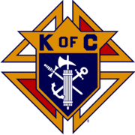](http://en.wikipedia.org/wiki/Image:Kofc.gif)

**Knights of Columbus**

**Father Diamond Council 6292**

The Council holds business meetings on the 2nd and 4th Tuesday’s of the month at 8 PM in Providence Hall at St Leo the Great Catholic Church. Web site**:** [**WWW.6292.kofc.com**](http://WWW.6292.kofc.com)**.** All meetings currently are hybrid (In person and virtual).

Annual Christmas Tree Sales commenced on 28 November and will go until 21 December. Trees are sold Wed thru Friday from 3:30 to 9 PM, Sat 9 AM to 9 PM,

And Sunday 9 AM to 6 PM. Location is next to St Leo’s School.

# December Activities:

* 4 December - Council Christmas Party
* 18 December – Feed the Homeless in DC
* 19 December – Family Breakfast and visit from Santa after 7:30 and 9 AM Masses
* 31 December - collect for KOVAR outside ABC Stores

**Albert Leightley:** [**Leightley8@verizon.net**](mailto:Leightley8@verizon.net)



On November 22nd, we presented 30 (an increase from 25 last year - an indication of need in or own community) Thanksgiving food baskets to [Main Street Child Development Center](https://www.mainstreetcdc.org/about) – our partner in providing holiday food to deserving neighbors in Fairfax City.  Families were selected by Main Street, and came to Main Street to pick up their Holiday Food.

[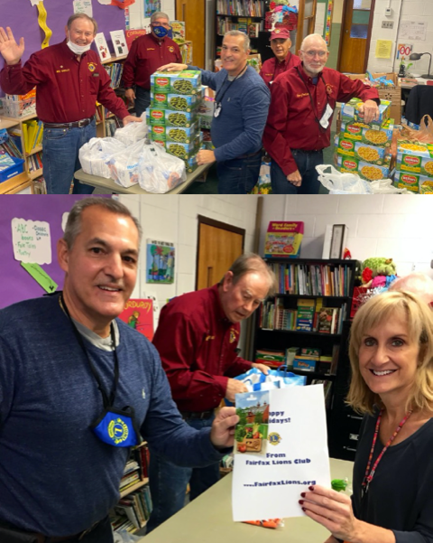](https://www.fairfaxlions.org/wp-content/uploads/2021/11/Screen-Shot-2021-11-23-at-9.25.16-AM.png)

2. Fairfax Lions thank our friends and neighbors for supporting our November fruit sale – the fruit was excellent, we sold out early, and all proceeds went to our charity programs.  Our sales capability   featured pre-ordering & pre-paying online, and scheduling a pick-up time.  This process reserves the fruit you select for you!

Sign up now for email notice of the December 16-18 sale, at: <https://www.fairfaxlions.org/citrus-sale-notification/>. Be sure to pre-order and we will hold for you the fruit you want! You will receive pre-order information by email.

[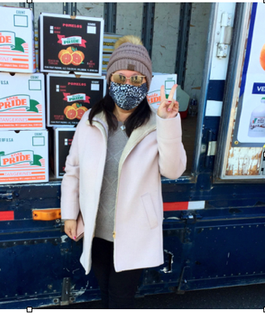](https://www.fairfaxlions.org/wp-content/uploads/2021/11/Screen-Shot-2021-11-23-at-9.32.30-AM.png)A happy customer picks up fruit she pre-ordered!

Fairfax Lions were assisted in the November sale by two volunteers from the Harley Owners Group.  Their participation was invaluable to support our sales staff over the 3 days, as we were not able to fully staff the sales positions with Lions Club members.  Thank you HOGs - you support directly contributes to supporting charity programs in our community.

**Gordon Tillery:** [**tilleryg@gmail.com**](mailto:tilleryg@gmail.com)

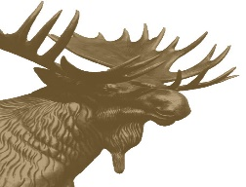

**Centreville Moose Lodge #2168**

The Centreville Moose Lodge is holding a special "Brunch with Santa" on Saturday, December 11 for kids up to the age of 12 years. Great food, fun games and a time to hang out with Santa Claus.  The Women of the Moose are sponsoring this event.  On Friday, December 10 we will hold our Annual Christmas Party at the Lodge which is free to all members.

On December 6 we will complete our first ever, stockings for the kids event supporting the Salvation Army.  We have sponsors for all the stockings we volunteered to deliver.

We are holding Bingo every Wednesday evening starting at 6:15 PM.  We will be closed Christmas eve so our staff can enjoy the time with their families.  Merry Christmas, everyone and a very Happy New Year.



CENTRAL FAIRFAX OPTIMIST CLUB

Our November Board and Club meetings were held at the VFW Post 8469 house. Mission BBQ was our caterer for the November 23rd meeting. We would appreciate any suggestions from ISCC members for other caterers for future meetings. One of our members, Bob Devery from Expedia Cruise Lines, talked about fun(d)raising opportunities for our club when you let him book your travel. He has been successfully supporting other clubs such as the Corvette Club, Commonwealth Swim Club, and others.

In November and December, the Central Fairfax Optimist Club is supporting needy families in Falls Church and Mountain View High Schools, Christmas bell ringing with the Salvation Army, character band-aids and toys for kids at the INOVA Fairfax hospital childhood cancer ward, the start of our Optimist Essay Contest, and a club holiday social.

During this time of giving, we have encouraged our members to donate to our Fairfax Youth Fund. To make a tax-deductible donation, they write a check payable to the Optimist International Foundation and in the memo line on the check put “Fairfax Youth Fund 16026.” That helps support all of our community service activities and scholarships.

We continue to support our Cub Scout Pack in Daniel’s Run Elementary. Nation-wide, there is concern about liability with the Boy Scouts. As members of Optimist International, each member is covered under a $1 million liability policy while we do community service..

**Dee Rushforth** deerush4th@aol.com



The Fairfax Rotary continues to meet virtually but will consider new options in January.  Our meetings continue to be interesting, including this past Monday’s presentation by Edward Maibach, Director of the Center for Climate Change at GMU.  Upcoming events include our Annual Christmas Holiday Gifts event for local children in conjunction with The Salvation Army.  We will also be participating with The Salvation Army on bell ringing at Safeway and Walmart over the next two weekends.  We have distributed our dictionaries to the 3rd graders in the city schools and will be delivering constitution booklets to 8th graders in January.

**Jennifer Rose**: Jennifer@cfcc.org



**Salvation Army**

**Women’s Auxiliary**

The Salvation Army Auxiliary has been busy assisting the Fairfax Corps with the holiday assistance program.  The group helped with preparing boxes for the Angel Tree and now are helping to put donations in the boxes.  The Auxiliary will meet both 12/1 and 12/8 to sort stockings.  Stockings are due back to the Corps no later than 12/3.  There are still opportunities for bell ringing with kettles being on site until 12/24.  Major Don Wilson at the Fairfax Corps is the Kettle contact - 703-385-8700.

**Connie Lauther:** [**lauthers2relo4u@cox.net**](mailto:lauthers2relo4u@cox.net)



**Sagan Brummett**

saganbrummett@**servicesource.org**



**Joe Meyer:** [**joe.meyer@shelterhouse.org**](mailto:joe.meyer@shelterhouse.org)



**Shepherd Center Fairfax Burke (SCFB)**

.

**Shepherd Center Fairfax Burke (SCFB)** SCFB is dedicated to helping older adults continue to live independently, and to providing enrichment and social networking

opportunities that keep life exciting and rewarding. Programs include Accompanied Medical Transportation and Companion Shopping (for older people who are no longer able to drive), Friendly Callers/ Visitors (for people who are mostly homebound), Caregivers Support Group (for those who have loved ones with dementia), low-cost exercise and yoga classes (to promote strength, balance and flexibility), and Lunch N’ Life, Adventures in Learning, and Wednesday at the Movies which all provide mental stimulation and socialization opportunities. For SCFB significant future and below activities see our web site [www.scfbva.org](http://www.scfbva.org).

DUE TO THE COVID RESTRICTIONS THE ONLY PROGRAMS CURRENTLY OPERATING ARE MEDICAL AND SHOPPING TRANSPORTATION IN BOTH FAIRFAX BURKE AND SOUTH COUNTY, CHAIR YOGA AND BOOK CLUB VIA ZOOM, FRIENDLY CALLER AND CARE GIVER PROGRAMS. AIL LUNCH N LIFE, FRIENDLY VISITOR, HANDY HELPER AND MOVIES ARE SUSPENDED UNTIL FURTHER NOTICE.

But Shepherd Center is still active, current activities,

1. Transportation Program –had 363 Medical and Shopping Drives by SCFB drivers during month.
2. Chair Yoga – SCFB Exercise Program conducted via Zoom, 3 times a week during the last month and average 59 participants per session.
3. Friendly Caller – made 111 contacts for the month.
4. Friendly Visitor – 18 during the month
5. Book Club - conducted two ZOOM meetings had 35 participants.
6. Handy Helper – Started up again and had 0 tasks for the month.
7. Held quarterly Board Meeting.

**Albert Leightley:** [***Leightley8@verizon.net***](mailto:Leightley8@verizon.net)

**Connie Lauther**

***Soroptimist International of Fairfax County***

We are fortunate to have several applicants for our female head of household grant, but that means a tough evaluation process. Christmas party is December 15.

**Cathy Kelleher: dandckelleher@cox.net­­­­­­­­­­­­­­­­­­­­­­­­­­­­­­­­­­­­­­­­­­­­­­­­­­­­­­­­­­­­**



**Woman’s Club of Fairfax**

Woman's Club of Fairfax November Newsletter

Members are donating coats to the Lamb Center.

We had a succesful bake sale at the recent Holiday Craft Show.

We are participating at the upcoming Fairfax Christmas Market, selling baked goods and hot chocolate and having a children's table where children can make Christmas decorations.

Woman's Club members are volunteering at the December City of Fairfax Band concerts, helping at will call and handing out programs, etc.  We are also collecting donated scarves and gloves for distribution to Afghan refugees.

We are collecting bottle caps for the Fairfax Methodist Church Preschool.  They will be recycled into a bench.

Hope everyone has a wonderful holiday season!

**Suzanne Grimsley: suzanne.grimsley@yahoo.com**



**Blanche Anderson:** [blanchewa@msn.com](mailto:blanchewa@msn.com)