**Inter-Service Club Council of the City of Fairfax**

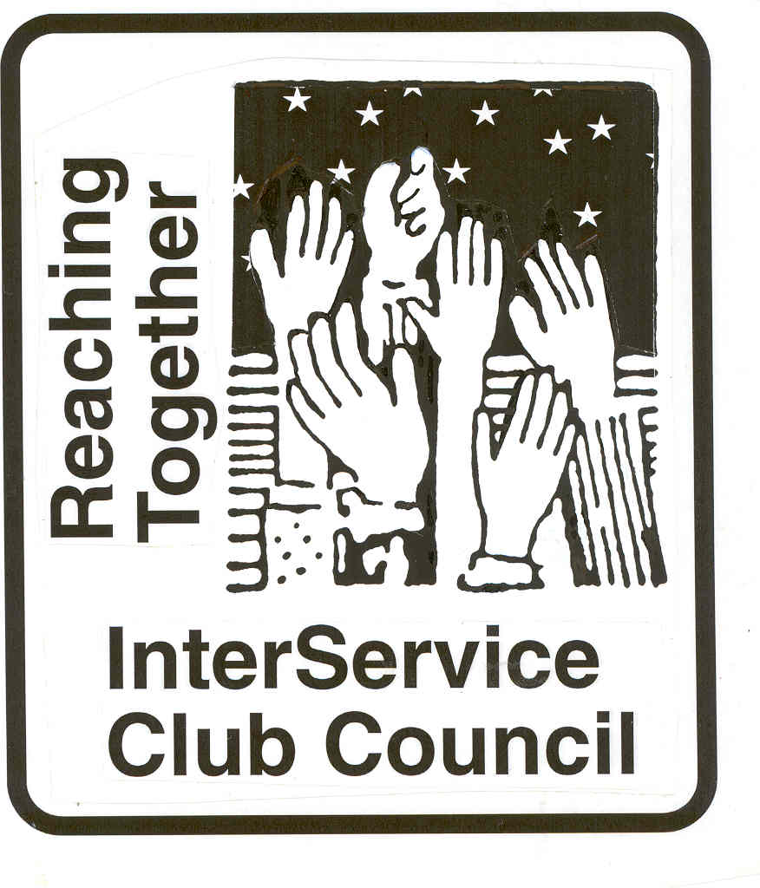

**iscc-fairfaxva.org**

Volume 47, Number 2 3 November 2021



***Next Meeting***:

Wednesday, 1 December, 2021

12:00 PM

American Legion

**ISCC Minutes**

**6 October 2021**

President Leightley called the meeting to order at 12;03 Pm. Fifteen members representing 17 organizations were present. Immediate Past President Larson gave the invocation, and all recited the pledge of allegiance.

OFFICER REPORTS

Minutes of the September meeting were approved as provided.

Vice President Grimsley reported that a representative from Service Source will speak at the November Meeting.

Treasures report was approved as provided. The proposed budget for the 2021-2022 Year was approved.

Immediate Past President Larson reported that he has photos from the VOY event. Organizations wanting photos should contact him as to which they might want.

President Leightley announced that next month and future lunches will be $9.00.

There was no Old Business

NEW BUSINESS

Immediate Past President Larson Installed President Leightley, who then installed Susan Grimsley as Vice President, Cathy Kelleher as Secretary, and Connie Lauther as Treasurer for the 2021-2022 term.

Representative gave Club reports.

The meeting was adjourned at 1:06 PM.

***City of Fairfax***

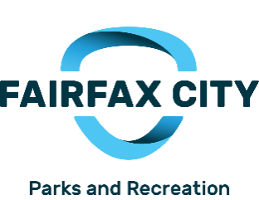

**35th Annual Holiday Craft Show**

**Sponsored by Fair City Mall**

Fairfax High School, 3501 Lion Run            
November 20, 2021, 10am - 5pm   
November 21, 2021, 10am - 3pm   
An annual show that provides an opportunity to purchase one-of-a kind handmade crafts such as baskets, dolls, and accessories, floral, jewelry, paintings, pottery/clay, and a multitude of wood items made by local and regional artists.  More than 200 juried crafters and gourmet food vendors participate.  $5 admission fee or $8 for a two-day pass.  For more information, call 703.385.7858 or visit [*www.fairfaxva.gov*](http://www.fairfaxva.gov)*/specialevents.*

**Festival of Lights and Carols**

**Sponsored by Fair City Mall**

December 4, 2021 12pm-6pm

Old Town Square, 10415 North Street

Holiday Festivities – 12pm – 6pm, Come listen to live holiday music, crafts and enjoy s’mores and hot cider at Old Town Square

Tree Lighting Ceremony - Come enjoy caroling and lighting of the Christmas at Old Town Square at 5:30pm.

**No charge. For more information, call 703.385.7858 or visit** [***www.fairfaxva.gov*/specialevents**](http://www.fairfaxva.gov/specialevents)

**Lunch with Santa**

**Sponsored by Fair City Mall**

December 11, 2021

Old Town Hall, 3999 University Drive

Children ages 10 and under can enjoy lunch with Santa at the Old Town Hall. There will be three lunch seatings will be offered – 11am, 12pm and 1pm. Tickets ($8 per child) will go on sale November 1 at the Parks & Recreation office at City Hall, Green Acres Center, and Sherwood Community Center or online. Limit of 10 tickets per person.

# Holiday Market

Old Town Square, 10415 North Street

Join us for the 5th Annual City of Fairfax Holiday Market in Old Town Square. Come and shop at the market of artisans as you enjoy Old Town Square in the heart of Historic Downtown Fairfax covered in holiday lights. The festival will include live holiday music, hot drinks, and gourmet treats and more!

The Holiday Market will be open the first 2 weekends of December on Friday, Saturday, and Sunday. Artisans will vary each weekend.

**Market Dates**Weekend 1: December 4,5, and 6 Weekend 2: December 10,11 and 12

|  |  |
| --- | --- |
| **Market Times**  Friday 5:00 – 8:00 PM  Saturday 12:00 – 6:00 PM  Sunday 12:00 – 5:00 PM |  |

**Mitzi Taylor** [**mitzi.taylor@fairfaxva.gov**](mailto:mitzi.taylor@fairfaxva.gov)**; Serrita Farnsworth** [serrita.farnsworth@fairfaxva.gov](mailto:serrita.farnsworth@fairfaxva.gov)

***Chocolate Lovers Festival Committee (CLFC)***.. ***Chocolate Lovers Festival Committee (CLFC)***

Mitzi Taylor [Mitzi.taylor@fairfaxva.gov](mailto:Mitzi.taylor@fairfaxva.gov)

***Independence Day Celebration Committee (IDCC)***.  ***Independence Day Celebration Committee (IDCC***

Brenda Brichant [bbrichnat@gamil.com](mailto:bbrichnat@gamil.com)

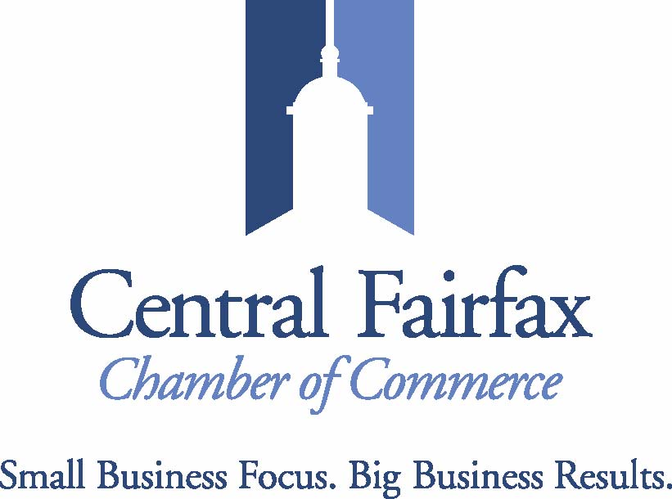

The Central Fairfax Chamber of Commerce is growing by LEAPS and BOUNDS! Not only has our membership grown, but also our benefits and programming as well. We have added 71 new members to the Chamber this year and since January of 2020, we have added nearly 15 NEW benefits of membership. It's been a while since we've submitted an update for the newsletter, so here are a few highlights of what we've been up to:

1.) Restaurant Week primary partner with the City. In 2022, we will have TWO Restaurant Weeks!

2.) Fall Festival's Carnival Alley - More than a dozen Chamber members participated this year, highlighting their businesses while providing FREE fun activities for families.

3.) On the Advocacy front, we are keeping an eye on the Stormwater Utility discussion and are offering webinars for commercial property owners to learn more and engage with the City. We are also monitoring the City's plans for the ARPA (American Rescue Plan Act) funds.

4.) We continue to host or co-host 8 - 12 events per month, including IN-PERSON and virtual networking, webinars, and committee events for Women in Business as well as our Young Professionals. Our calendar includes listings for more than 60 events per month! These listings include member events and partner events.

5.) Come see us at Old Town Hall on Small Business Saturday (November 27) from 9am - 2pm. We will be promoting the Elf Hunt, offering up free coffee, hot chocolate and other treats from Cameron's Coffee and Chocolates and will operate a free gift-wrapping station. We are proud to be working with the Old Town Fairfax Business Association and the Fairfax City Economic Development Office for the 3rd year in a row!

Lastly, I would be remiss if I didn't remind you that each of your organizations is eligible to join the Central Fairfax Chamber of Commerce. Dues are $175/year for nonprofits. I'm happy to sit down with you and share how the 23 nonprofits who are in the Chamber are leveraging their membership to support their respective missions. Feel free to email me at [executivedirector@cfcc.org](mailto:executivedirector@cfcc.org).

**Jennifer Rose:** [**Jennifer@cfcc.org**](mailto:Jennifer@cfcc.org)

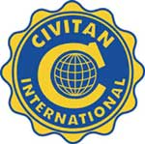**Civitan Club of Fairfax**

The beer garden at the Fairfax Fall Festival was fun. And now that the Pandemic has eased a bit, we at Fairfax Civitan are increasingly involved in small group, person-to-person volunteer programs and fund-raising projects. Some of our “old reliables” are again providing funds that we can give away to worthy organizations, including especially organizations that support folks with Intellectual and Developmental Disabilities (I-DD).

The ServiceSource executive who spoke at our 7 October Zoom Club meeting talked about ways that organization has continued pursuing its mission during the Pandemic, and he talked about plans for the future. At our 4 November Club meeting, our scheduled speaker is JoAnn O’Toole, the President Elect of Civitan International. She will discuss current challenges and opportunities confronting Civitans, and she also will talk about her goals when next year she becomes the President of our International organization.

Our 21 October Fairfax Civitan BOARD meeting had two focuses. We spent some time-sharing ideas about recruiting and retaining new members (a current challenge for many organizations, I suspect.) Our other focus was on fall and winter service projects. As will be further discussed at our November Club meeting, we have started a Food for Others drive; there will be a December Toys for Tots collection; we are providing modest cash card gifts to I-DD Club members who live in small group homes; and a January drive to collect blankets for the children in a live-in school in Africa is being planned.

**David Hartmann:**[**chartmann@cox.net**](mailto:chartmann@cox.net)

**Downtown Fairfax Coalition**

**Jim Wyckoff, Jr.: jcwyckoffjr@aol.com**

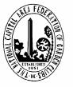 **FAIRFAX FERNS GARDEN CLUB**

Next meeting is November 8 Agenda:

6:30-7 pm: Coffee & Conversation: Hostess: Mariann Kowalski

7 pm Program: Creative Solutions For Drainage. Louis Ratchford, Merrifield Plant Specialist:

“Louis loves helping people select plants to develop their dream gardens. As a member of our trees and shrubs team at our Fair Oaks location, you’ll often see Louis wearing his friendly smile and pointing out beautiful and fragrant plants to customers and coworkers alike. A true cheerleader for new and unique plants, Louis’ passion is infectious–he often has the entire nursery team excited about our latest additions. When he’s not at work or in the garden, Louis spends his time offering friends and family his gardening advice so they too can enjoy the beauty of nature.”

8 -8:50 pm Business Meeting

Ferns will decorate Old Town Hall on Nov 29 ..

**Kathy Hoffman:** [Kathryn.j.hoffman@gmail.com](mailto:Kathryn.j.hoffman@gmail.com)

**Fairfax VA Harley**

**Owners Group**

Fall is a great time of the year for riding and enjoying all of the terrific roads and fall foliage in Virginia. As we head for the holiday season riding gives way to getting involved with family and friends and giving back along the way.

On October 27th Chapter members dressed up themselves and their bikes in Halloween costumes and rode in the Vienna 75th Annual Halloween Parade. As always this is a great community event, well attended by all ages.

The Chapter generates funds from rides in October and November that will be used to provide a Thanksgiving dinner on November 24th for people supported and served by The Lamb Center. The Chapter and members donate food and service to make this truly a family style event. Several Chapter members will be involved in serving and helping with the meal. We look at the Lamb Center as close neighbors and are proud to support.

The Chapter has again enthusiastically joined with the Salvation Army’s Holiday Program. The program will be pretty much back to normal following challenges of the pandemic. We will be back for Holiday Stockings are being filled with all kinds of surprises for kids and families in Fairfax County who otherwise would not have much. Gift Cards are also welcome and will be used by the families to purchase gifts and needed food. Chapter members will also be on hand before Christmas to assemble bikes and then assist with distributing the Holiday packages to families in need.

The Fairfax Harley Owners Group is a diverse and energetic force of 320 members. The Chapter publishes a monthly newsletter and maintains its own web page at [www.fairfaxhog.com](http://www.fairfaxhog.com) . If you wish to know more, please contact me.

**Larry** **Larson: larry.d.larson@verizon.net**

**Fairfax City**

**Regional Library**

**City oFairfaxLibrary**

**10360 North Street**

**Fairfax, VA 22030**

703-293-6227 | TTY: 711

Sun.: 1 p.m. - 5 p.m.

Mon. - Thurs.: 10 a.m. - 9 p.m.

Fri.: 10 a.m. - 6 p.m.

Sat.: 10 a.m. – 5 p.m.

The City of Fairfax Regional Library offers a wide range of events for all ages, including children’s programs, ESL Conversation groups and tutoring, technology help, book discussions, genealogy and local history programs, and much more.

<http://www.fairfaxcounty.gov/library/events/>

We are not being inundated with books as we had feared.

We are being very selective of the books we keep for resale.

Check out the "free carts" on the 1st floor near the elevator in the lobby and on G2 near the cage.

We will have a great sale in April. Meanwhile check out our on-going sale near the reference desk.

.**Katie Clary**: [kvclary@mindspring.com](mailto:kvclary@mindspring.com)

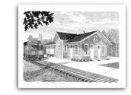

**Friends of**

**Fairfax Station**

**N Gauge Model Trains Running at the Fairfax Station Railroad Museum**

**N Gauge Model Trains will be running at the Fairfax Station Railroad Museum on Sunday, November 21, 2021 from 1-4 p.m.  The Station is located at 11200 Fairfax Station Road in Fairfax Station, VA.  Admission: Children 4 and under and Museum members, free; ages 5-12, $3; ages 13 and older, $5, special events, $6; Seniors and military (active and retired) $4.** [**www.fairfax-station.org,**](http://www.fairfax-station.org,)[**www.facebook.com/FFXSRR,**](http://www.facebook.com/FFXSRR,) **703-425-9225.**

**Pete Conklin:** [**conklinps@aol.com**](mailto:conklinps@aol.com)

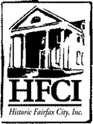

The November **meeting of HFCI’s Board will be held November 10 at 7PM. If you would like to join us, let me know**.  **(location to be announced)**

**The HFCI Board has filled the 20 member status but if you are interested in serving, please call and you will be placed on a waiting list.**

If you are a member of a club or organization and would like to know about what HFCI represents, ask for a 20 minute presentation. Call Al Leightley at 703 273 2089.

As a member of HFCI, not only are you supporting history, you receive a discount on

products in our gift shop and you also receive a quartley newsletter which features a local historical story each issue. Please pick up a brochure and send in your application.

Are you interested in being a volunteer or docent for historic sites? Call 703 385 8415 and find out more about it. Would you like to be remembered forever as a citizen of Fairfax? Buy a brick with your name on it for $100. The bricks are placed in front of the Fairfax Museum.

The Fairfax Museum and the Blenheim Center are open for visitors. Docents at the sites are back and tours are being held. Rentals for the space is open. Masks are mandatory

indoors.

THE WHITE HOUSE ORNAMENTS ARE IN: HFCI will be selling them at the Craft Fair November 20-21. Cost is $22.00 (Also available at the Museum and Blenheim.

**Programs at the Fairfax Museum and Blenheim:**

**MUSEUM: Programs are at 2PM every other Sunday**

**Fairfax Museum and Visitor Center 10209 Main Street, 703 385 8414**

**Sunday, November 7 • 2 p.m**.  *In-Person at the Fairfax Museum and Visitor Center, but limited to 20 guests.*

*The Golden Age of The Washington Post*  with Bob Levey, former *Washington Post* columnist. Book sales and signing of Levey’s novel, *Larry Felder, Candidate* (the story of a journalist who runs for Congress) will follow the talk. Call 703.385.8415 for reservations.

**Saturday, November 20 • 2 p.m**. • In-person at Historic Blenheim

*“Faces of Union Soldiers at South Mountain and Harpers Ferry”*

Historians and authors Joseph Stahl and Matthew Borders will take you through the lives of the common soldiers who fought for the Union in Frederick County, Maryland at Harpers Ferry, Virginia prior to the horrific battle at Antietam.  The faces of these soldiers are a starting point to where we will learn about the individual soldiers—their names, history, and army experiences.  Their book of the same title will be available for sale and signing.

**DECEMBER PROGRAM AT HISTORIC BLENHEIM!!!**

**CHRISTMAS IN CAMP, IN-PERSON is BACK!  It will be SUNDAY, DECEMBER 5, from Noon-4pm.**

We will have our regular outdoor components of two small camps of Union and Confederate.

**EXHIBITS**

**Fairfax Museum and Visitors Center**

October thru December:”The Long Tradition of Virginia Canneries**” A Traveling exhibit from the Blue Ridge Institute in Ferrum.** Stories from cannery workers, production images and displays of canning equipment.

**Website: historicfairfax.org**

**Hildie Carney:** [**hilcarn31@aol.com**](mailto:hilcarn31@aol.com)

**Kiwanis International**

**Kiwanis Club**

**of Fairfax**

We will be working on getting a family for Thanksgiving.

**Mariann Gabor****mgabor2010@hotmail.com**

[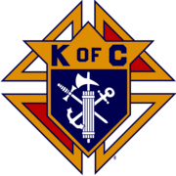](http://en.wikipedia.org/wiki/Image:Kofc.gif)

**Knights of Columbus**

**Father Diamond Council 6292**

The Council holds business meetings on the 2nd and 4th Tuesday’s of the month at 8 PM in Providence Hall at St Leo the Great Catholic Church. Web site**:** [**WWW.6292.kofc.com**](http://WWW.6292.kofc.com)**.** All meetings currently are hybrid (In person and virtual).

# November Activities:

* 6/7 November – Commence Keep Christ in Christmas card sales at St Leo’s
* 15 November – Bingo at Fairfax Nursing Home?
* 20 November – Thanksgiving Food Baskets Distribution at St Leo’s
* 20 November – Feed the homeless in DC.
* 21 November – Family Breakfast at Providence Hall
* 26 November - 6 PM Lighting of the Cheche at St Leo’s
* 26 November – 6:30 PM – Spaghetti Dinner St Leo’s Gym

28 November – Commence Annual Christmas Tree Sales at St Leo’s

**Albert Leightley:** [**Leightley8@verizon.net**](mailto:Leightley8@verizon.net)

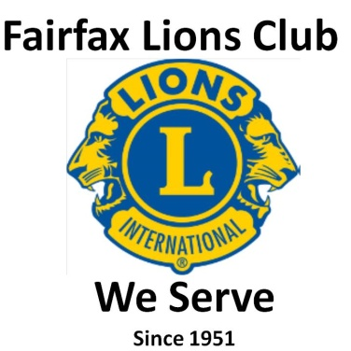

* Fairfax Lions participated, on October 23, in DogFest 21 (Restoin Town Center) and presented donations to Canine Companions for Independence.

page1image142346592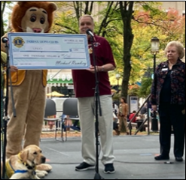

* Lions had a great day at the City of Fairfax Fall Festival on Oct 9th, and appreciate being on the City’s beer/wine team.

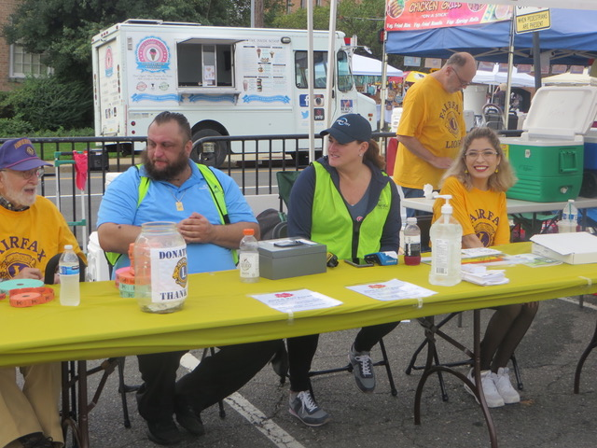

* The Lions November Citrus Fruit Sale is Nov 18-20.  Pre-order at::  <https://fairfaxlions.square.site>

**Gordon Tillery:** [**tilleryg@gmail.com**](mailto:tilleryg@gmail.com)



**Centreville Moose Lodge #2168**

Through our food donation collection program, we were able to donate approximately 50 pounds of food to the VanDyke Park Blessing box sponsored by the Girl Scouts. We also donated fried chicken dinners to the Robinson House half-way center to feed 20 people.

During the month of October we conducted our Rock the Cradle campaign raising funds supporting the kids at Mooseheart School. On Sunday, October 24, we held an open House at the Moose Lodge at 3529 Chain Bridge Road. We provided a free pancake and sausage breakfast from 8:00Am to 11:00 AM. We invite all City officials and various leaders of Civic Organizations as well as the general public to attend.

Our Friday night dinners continue. Our dinner on November 12 is dedicated to our Valued Vets and all Moose Members with Valued Vet status will receive their dinner courtesy of the Lodge. December 11 we will hold a Brunch with Santa party for the kids.



We have a new home - a wonderful and safe place to meet where we are able to reduce our Covid exposure. With some exceptions, most of our Board (2nd Tuesday) and Club (4th Tuesday) meetings will be held at the VFW Post 8469 house. We will have exclusive use and have access to kitchen, bathroom, and meeting room facilities.

In this first Optimist quarter, we have a Halloween club social, monthly Fairfax City Inter-Service Club Council meetings, a District meeting, a November speaker talking about Historic Fairfax Railroad Station & Community Service Potential with Fairfax Lions Club, needy family support for Thanksgiving and Christmas, bell ringing with the Salvation Army, toys for kids and the INOVA Fairfax hospital childhood cancer ward, the start of our Optimist Essay Contest, and a club holiday social.

We welcome our newest member, Bruce Lauther. He is an experienced Optimist and will be a great asset to our Club.

**Dee Rushforth** deerush4th@aol.com



The Rotary Club of Fairfax continues with virtual (Zoom) meetings and will continue to do so through the end of the year.

Our major fundraiser right now is the 50/50 Great Odds Raffle. We are challenged to sell no more than 100 tickets at $100 per ticket. 50 percent of the dollar amount of entries (e.g., if we succeed at selling 100 tickets the winner will receive $5000!). I believe there are only 8 left as of today’s board meeting (Tuesday November 2, 2021), so time is of the essence. Regardless, the entry window will close on November 15th at midnight. Go to our home page, <http://fairfaxrotary.org> to register.

We are also in the process of distributing dictionaries to 3rd graders in the city and working with the school staff on the best way of presenting them. The response of the students and teachers has been great again this year. Apparently, hard copy dictionaries are very well received and used, perhaps a bit novel in this “on-line” world.

We are working with The Salvation Army to provide gifts and an outreach celebration on December 13th, for local children and families to brighten the holidays. We expect approximately 35 children and will provide individual gifts based on their lists. We will again work with the Legion to have the event in the parking lot. Although we will not be inside again this year, we expect to have the Fire Department as well as a few “special guests”, perhaps including the Chick-Fil-A, Santa Cow. We are also working with the Salvation Army to continue our bell ringing at local Super Markets.

October was “Polio Eradication” month for The Rotary organization and we continue to contribute with Rotary International to wiping out this dreadful disease. I believe there are only two countries that have had cases in the last year.

**Jennifer Rose**: Jennifer@cfcc.org



**Salvation Army**

**Women’s Auxiliary**

The Auxiliary will be assisting with holiday preparations this month.  Boxes for families receiving assistance will be put together and filled stockings checked for inappropriate items such as candy and other food.  To date over 1000 children, ages infant to 12, from the Central Fairfax area have been registered.  Stockings are still available. Stacy Burke (703-385-8700 ext 11) at Corps Hdqtrs will have them available for pick up.  Angel Tree Tags are available for individuals or a family.  Clothing and toy suggestions from parents are listed on each tag for children 12 and under. The suggested expenditure per child would be approximately $75.00 but to not exceed $125.00. Call Major Jean Wilson at 703-385-8700 ext 21 for the Angel Tree program.  Stockings are due back at Hdqtrs December 3.  Angel Tree items are due back by December 7.

.

**Connie Lauther:** [**lauthers2relo4u@cox.net**](mailto:lauthers2relo4u@cox.net)



**Sagan Brummett**

saganbrummett@**servicesource.org**



**Joe Meyer:** [**joe.meyer@shelterhouse.org**](mailto:joe.meyer@shelterhouse.org)



**Shepherd Center Fairfax Burke (SCFB)**

.

**Shepherd Center Fairfax Burke (SCFB)** SCFB is dedicated to helping older adults continue to live independently, and to providing enrichment and social networking

opportunities that keep life exciting and rewarding. Programs include Accompanied Medical Transportation and Companion Shopping (for older people who are no longer able to drive), Friendly Callers/ Visitors (for people who are mostly homebound), Caregivers Support Group (for those who have loved ones with dementia), low-cost exercise and yoga classes (to promote strength, balance and flexibility), and Lunch N’ Life, Adventures in Learning, and Wednesday at the Movies which all provide mental stimulation and socialization opportunities. For SCFB significant future and below activities see our web site [www.scfbva.org](http://www.scfbva.org).

DUE TO THE COVID RESTRICTIONS THE ONLY PROGRAMS CURRENTLY OPERATING ARE MEDICAL AND SHOPPING TRANSPORTATION IN BOTH FAIRFAX BURKE AND SOUTH COUNTY, CHAIR YOGA AND BOOK CLUB VIA ZOOM, FRIENDLY CALLER AND CARE GIVER PROGRAMS. AIL LUNCH N LIFE, FRIENDLY VISITOR, HANDY HELPER AND MOVIES ARE SUSPENDED UNTIL FURTHER NOTICE.

But Shepherd Center is still active, current activities,

1. Transportation Program –had 328 Medical and Shopping Drives by SCFB drivers during month.
2. Chair Yoga – SCFB Exercise Program conducted via Zoom, 3 times a week during the last month and average 60 participants per session.
3. Friendly Caller – continued making 37 contacts for the month.
4. Book Club - conducted virtually monthly and had 35 participants.
5. Handy Helper – Started up again and had 1 task for the month.
6. Oct 9th SCFB supported the evening Beer Garden at Fairfax City Fall Festival

**Albert Leightley:** [***Leightley8@verizon.net***](mailto:Leightley8@verizon.net)

**Connie Lauther**

***Soroptimist International of Fairfax County***

Successful ornament sale at the Fall Festival. We are postponing our yard sale until spring due to organization and storage issues.

**Cathy Kelleher: dandckelleher@cox.net­­­­­­­­­­­­­­­­­­­­­­­­­­­­­­­­­­­­­­­­­­­­­­­­­­­­­­­­­­­­**



**Woman’s Club of Fairfax**

Our November speaker was Carolyn Sutterfield, with Fairfax Area Commission on Aging.  She discussed resources for seniors and aging in place.  She also spoke about Fairfax City's efforts to establish Fairfax Village in the City, a public-private initiative that aims to keep a sense of connection with older residents by providing volunteer and resource services for various needs:  transportation, light housekeeping, home repairs, etc.  There will be a part-time city employee as a coordinator whom people can call to get referrals to the appropriate services or just check-in phone calls.  The goal is to assist seniors to be able to stay in their homes as long as possible.

The Woman's Club will sell baked goods at the Fairfax City Holiday Market.

Members of our Club will volunteer at the Fairfax City Christmas Band concert.  The Band is also coordinating a drive to collect scarves and hats for Afghan refugees, and we will donate to that.

We are adopting a family for Christmas, providing food and presents.

Our club donated 30 filled Christmas stocking to the Salvation Army's stocking drive.

The Woman's Club will have a booth at the Fairfax City Holiday Market on December 5, selling hot chocolate and goodies.  We will also have a children's table with Christmas decoration makings, which has been a great success in the past.

Our club is a participant in the Shot@Life program, which educates and advocates that vaccines are made available worldwide.

Members are collecting caps for the Fairfax United Methodist Church Preschool.  The caps will eventually be recycled and used to build a bench.

Our "Flower Power" fundraiser is doing well ... it is an on-line site of flower bulbs and Christmas wreathes that people can order on their own and the club gets a percentage of the profits.

**Suzanne Grimsley: suzanne.grimsley@yahoo.com**



As many of you know, I am a member of Zonta International, an organization whose mission is to enhance the status of women and girls worldwide. My local Zonta Club of Fairfax is holding two online fundraisers this Fall with 100% of the profit going to fund scholarships for women in need in my county. Please consider supporting one or both of these fundraisers to help us in our quest to better the lives of these women. Your order will be shipped directly to you making it easy to participate. With the holidays right around the corner, both fundraisers provide an opportunity for you to get started on your shopping while helping a worthy cause at the same time.

Abbycandles.com offers a selection of various candles in a variety of fragrances as well as cookie dough, popcorn, and other items. When shopping, simply input our seller ID (63531) at Checkout to ensure that your order counts for our fundraiser. The only shipping option is to you, not the organization so you can be assured of receiving your order timely.

BoonSupply.com offers all sorts of items from various types of bags and containers to household items. Once at the site, click on “Find a Fundraiser”, and then enter “Zonta Club of Fairfax”. Then click “Shop This Cause”.

Due to COVID 19, our usual fundraisers have not been viable as they are all in-person events. We have had to be creative in continuing our fundraising in a safe manner via these two online opportunities. I very much appreciate any support you provide for these fundraisers.

﻿ Zonta has an annual wreath sale. Beautiful fresh wreath for $39.

We have ordered them for a few years and have been happy each year with how fresh they are, how long they last and how pretty they are. If anyone wants to order one, they may email Joe Furman at [jlfigf@me.com](mailto:jlfigf@me.com), leave your name, say your part of ICC and I can deliver them to the December 3rd meeting for pickup.

Orders must be made before November 17.

**Blanche Anderson:** [blanchewa@msn.com](mailto:blanchewa@msn.com)