**Inter-Service Club Council of the City of Fairfax**

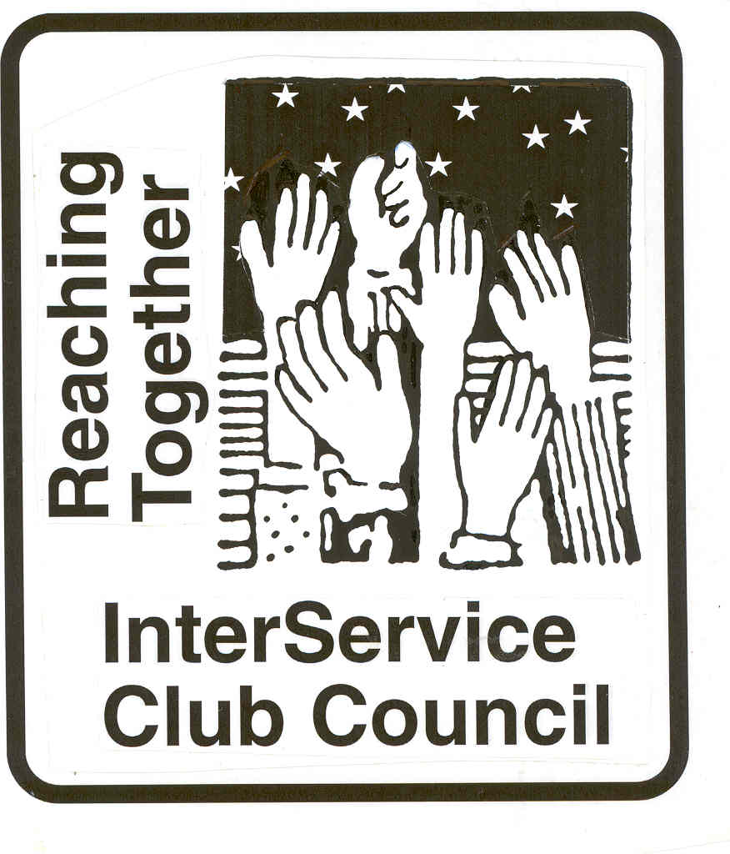

**iscc-fairfaxva.org**

Volume 47, Number 7 6 April 2022



***Next Meeting***:

Wednesday, 4 Mayl 2022

12:00 PM

Moose Lodge

**ISCC Minutes**

ISCC Minutes 2 March 2022

President Leightley called the meeting to order at 12:00PM. Forteen members were present. James Davenport was a guest and speaker. Connie Lauther gave the invocation, and all recited the Pledge of Allegiance.

OFFICER REPORTS

Minutes of the February meeting were approved as provided.

Treasurer’s report was approved as provided.

Vice President Grimsley had nothing to report

Immediate Past President Larson had nothing to report.

President Leightley reported that the Fairfax City Parks and Recreation acknowledged the city will

cover the lability insurance for Volunteer of the Year event but the decision of the EXCOM was to continue the additional liability insurance as contingency.

Mr. Davenport (TDM/VDOT) gave a presentation on the I-66 reconstruction efforts and the express lanes are to be completed by Dec 2022. Dates of completing the entire project are unknown.

NEW BUSINESS

Larry Larson provided the plan for Volunteer of the Year for 21-22. He encouraged the reps to bring the required nominee date of 15 May 2022 up to their presidents. Formal requests will be made by the end of March. Jennifer Rose made a recommendation that we include a VoY from the Fairfax City School System. Al Leightley indicated he would contact the school board to see about their interest.

There being no other business, Club representatives gave their reports.

The meeting was adjourned at 1:15 PM.

***City of Fairfax***



**Upcoming Events:**

**Whiskey Basics**

Saturday, May 16

Historic Blenheim

3PM and 5PM Session

This event will feature Mularkey Distillery, as they walk us through a whiskey tasting on the beautiful ground of Historic Blenheim. There are two sessions available, one at 3PM and the second at 5PM. Participants can register for a 6-person table at either session for $150. Live music will also be provided by a favorite, local performer, Rob Hornfeck. Tickets are still available for anyone who’s interested in registering for this event.

**Fairfax Uncorked, Jazz and Wine Festival**

Saturday, May 7

Historic Blenheim

3:30 – 8PM

NEW THIS YEAR! The city is thrilled to announce its first ever, Jazz and Wine Festival- Fairfax Uncorked! This event will feature the wonderful sounds of Mason Jazz musicians while participants enjoy the fine fruits of local Virginia wineries. Non-drinking tickets are $10 a person, and drinking tickets are $25 a person. Drinking tickets also include an official Fairfax Uncorked wine tasting glass. Registration is open at this time.

………………………………………… **Chocolate Lover Festival**

**Chocolate Lovers Festival Committee**- Nothing new to report at this time. Meetings will resume again in September 2022.

………………………………………… Mitzi Taylor [Mitzi.taylor@fairfaxva.gov](mailto:Mitzi.taylor@fairfaxva.gov)



***Independence Day Celebration Committee (IDCC)***.  ***Independence Day Celebration Committee (IDCC***

**Independence Day Celebration Committee-** Parade applications were due April 1, however, if there’s anyone who’s still interested in applying, please do so ASAP. IDCC is currently in the process of getting this year’s t-shirts, so please let us know if you’re interested in purchasing one. Additionally, there will also be bucket hats for sale, in additional to the traditional baseball caps, for purchase this year.



**Jennifer Rose:** [**Jennifer@cfcc.org**](mailto:Jennifer@cfcc.org)

**Civitan Club of Fairfax**

A major fundraiser for CIvitans, the Arlington Virginia Garage Sale (huge flea market) begins the new year on 2 April 2022. Hopefully, the Pandemic will remain "quiet" enough that dozens of vendors and shoppers will do business face-to-face--carefully and with face masks recommended. The sale will continue the first Saturday of each month from April through November. Run for many years by the Arlington Civitan Club, the Fairfax Civitan Club now provides substantial support for the effort, in particular running the food stand. The Garage Sale takes place in a multi-level parking garage, that during the week supports the Arlington school system. The sale supports Arlington County by providing one place where both individual Arlington residents and professional vendors can bring merchandise to sell (from tools to clothes, from knickknacks to books, and everything in between). Vendors are charged for the use of "parking spaces" and this money (after expenses) is used by Civitans to support various worthy organizations and activities.

Our regular Club zoom meeting takes place on Thursday 7 April. Beside tending to a lot of business, there are two speakers and programs. One is about the Northern Virginia Therapeutic Riding Program. Civitans and the Foundation for Children with Intellectual and Developmental Disabilities (FCIDD) have been among the supporters of NVTRP. Also, later in the month, some of our Club members will be meeting and touring at the expanded and renovated NVTRP facilities. The second program at our Club meeting is about Proud Hearts—a Club especially for people with disabilities, which is sponsored by Fairfax Civitans and by ServiceSource.

On 8-9 April, the spring meeting of the Chesapeake District will be held—person-to-person at Ocean City, but also offered via zoom. During this time frame, the Board of the Foundation (FCIDD) will meet (also in person or by zoom). A number of Fairfax Civitans are officers in the District and/or in the Foundation and will be attending. Among other things, the FCIDD will make final decisions about the recent request for funds initiated by ServiceSource and sponsored by Fairfax Civitan.

.

**David Hartmann:**[**chartmann@cox.net**](mailto:chartmann@cox.net)

**Downtown Fairfax Coalition**

**Jim Wyckoff, Jr.: jcwyckoffjr@aol.com**

 **FAIRFAX FERNS GARDEN CLUB**

The April meeting of the Fairfax Ferns will be held on April 11th at the Fairfax Library at 7PM.

The program will be a presentation on the Kitty Pozer Garden in preparation for the Virginia Garden Tour

on April 26th at the Ratcliff Allison Pozer House.  The Garden will be featured and tours will be guided by

the member docents from the garden club.

The club members are also weeding, planting and working to make the garden "tour perfect"

**Kathy Hoffman:** [Kathryn.j.hoffman@gmail.com](mailto:Kathryn.j.hoffman@gmail.com)

**Fairfax VA Harley**

**Owners Group**

# Fairfax Harley Owners Group

# Fairfax VA Harley Owners Group

Our 2022 activities are ready to roll and we have some terrific new rides planned for the rest of the riding season. We will be out on April 1st collecting trash along Fairfax Boulevard and in front of City Hall. This is a great community effort that builds pride in our community and generates a lot of good will.

After a two year hiatus, work continues on our 22nd annual “Ride of the Patriots” event on Sunday, May 29th. Our program for this event will be similar to previous years and will feature a short parade, an opening ceremony to honor those in uniform who serve our nation and protect our liberty. This year the Ride of the Patriots will join Rolling To Remember at the RFK Stadium. We encourage you to check out the website at [www.rideofthepatriots.com](http://www.rideofthepatriots.com/). This is a community event and everyone is invited to come. This event attracts riders from across the USA to remember and honor friends and relatives in uniform who have served our nation unselfishly.

If there is an interest by any of the City of Fairfax InterService Council member groups in participating, please let me know. Your questions or suggestions will be most welcome.

The Fairfax Harley Owners Group is a diverse and energetic force of over 250 members. The Chapter publishes a monthly newsletter and maintains its own web page at [www.fairfaxhog.com](http://www.fairfaxhog.com/)

**Larry** **Larson: larry.d.larson@verizon.net**

**Fairfax City**

**Regional Library**

**City oFairfaxLibrary**

**10360 North Street**

**Fairfax, VA 22030**

703-293-6227 | TTY: 711

Sun.: 1 p.m. - 5 p.m.

Mon. - Thurs.: 10 a.m. - 9 p.m.

Fri.: 10 a.m. - 6 p.m.

Sat.: 10 a.m. – 5 p.m.

The City of Fairfax Regional Library offers a wide range of events for all ages, including children’s programs, ESL Conversation groups and tutoring, technology help, book discussions, genealogy and local history programs, and much more.

<http://www.fairfaxcounty.gov/library/events/>

.**Katie Clary**: [kvclary@mindspring.com](mailto:kvclary@mindspring.com)

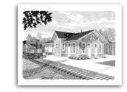

**Friends of**

**Fairfax Station**

**On Tuesday, April 26, 2022 from 1-4 p.m., ticket holders for this year's Historic Garden Week tour, sponsored by the Garden Club of Virginia, will be able to tour the Railroad Museum with its historic displays of railroading and railroad artifacts as well as displays of local history.  The Museum is a Certified Natural Habitat, making it an ideal site for tour participants to explore Virginia's history and natural treasures.  For garden tour tickets, visit vagardenweek.org.** [**www.fairfax-station.org,**](http://www.fairfax-station.org,) [**www.facebook.com/FFXSRR**](http://www.facebook.com/FFXSRR)

**The Fairfax Station Railroad Museum will be open to the public on Sunday, April 24, 2022 from 1-4 p.m. In addition to our regular exhibits there will be hundreds of model locomotives, train cars and accessories available for purchase.  All items are used but in very good to excellent condition.  Proceeds are used to support museum operations.  Please DO NOT bring items for donation.  Admission:  Museum members and ages 4 and under, free; ages 5-12, $3; ages 13 and older, $5 ($6 special events); seniors and military, active and retired, $4.** [**www.fairfax-station.org,**](http://www.fairfax-station.org,)[**www.facebook.com/FFXSRR,**](http://www.facebook.com/FFXSRR,) **703-425-9225.**

Tabletop (T-TRAK) model trains will be on display and running at the Fairfax Station Railroad Museum on Sunday April 10, 2022 from 1-4 p.m.  The Museum is located at 11200 Fairfax Station Road in Fairfax Station, VA.  Admission:  Museum members and ages 4 and under, free; ages 5-12, $3; ages 13 and older, $5 ($6 for special events); seniors and military, active and retired, $4.  [www.fairfax-station.org,](http://www.fairfax-station.org,) [www.facebook.com/FFXSRR,](http://www.facebook.com/FFXSRR,) 703-425-9225.

**Pete Conklin:** [**conklinps@aol.com**](mailto:conklinps@aol.com)



**John Keith: jkeith@bklawva.com**

**Kiwanis International**

**Kiwanis Club**

**of Fairfax**

We will be helping with the Library book sale

We will be doing meals for young minds

**Mariann Gabor****mgabor2010@hotmail.com**

[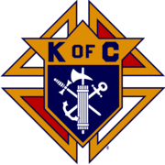](http://en.wikipedia.org/wiki/Image:Kofc.gif)

**Knights of Columbus**

**Father Diamond Council 6292**

The Council holds business meetings on the 2nd and 4th Tuesday’s of the month at 8 PM in Providence Hall at St Leo the Great Catholic Church. Web site**:** [**WWW.6292.kofc.com**](http://WWW.6292.kofc.com)**.** All meetings currently are hybrid (In person and virtual).

# March Activities:

- Mar 30 – April 3 KOVAR Charity Collections

- April 11 – Bingo at the Fairfax Nursing Home

- April 17 – Easter Egg Hunt after 9 AM, 11 AM, and 1 PM Masses

- April 23 – Food Concession at Fairfax History Day

- April 29 – 30 - State Convention at Virginia Beach

**Albert Leightley:** [**Leightley8@verizon.net**](mailto:Leightley8@verizon.net)



**Gordon Tillery:** [**tilleryg@gmail.com**](mailto:tilleryg@gmail.com)



**Centreville Moose Lodge #2168**

Through our food donation collection program, we have been able to donate approximately 350 pounds of canned goods and 50 pounds of frozen meats and meals to the Robinson House half-way center on the month of March.

We are extremely proud to be the sponsor for the Appalachian Honor Flight on April 22. We will host 25 veterans and their escorts for dinner on Friday evening at the Moose Lodge. Anyone interested in greeting the veterans as they arrive on their bus please join us at the Centreville Moose Lodge (3529 Chain Bridge Rd, Fairfax, VA) at 6:00PM.

We have also made arrangements to provide the Appalachian Honor Flight with box lunches as they tour DC on Saturday, April 23.

We continue to offer free Texas-Hold-Em games on Tuesday evenings (7PM) and Sunday afternoons (2PM), Bingo every Wednesday evening for 6:15 to 9:30PM, Taco Thursdays from 4:30-8PM and Friday Night dinners from 5:30-8PM.

**Herb Zimmerman herb2777@yahoo.com**



CENTRAL FAIRFAX OPTIMIST CLUB

The Central Fairfax Optimist club held their annual Oratorical Contest virtually on March 28th and 29th.  It was an incredible group of young people who spoke on the topic:  "Staying Optimistic in Challenging Times."  There were 13 contestants ranging in ages from 9 to 16 years.   The first place winner was Ryan Augustine from Woodson High School, Fairfax; 2nd place winner was Elaina Jacob from Eagle Ridge Middle School, Ashburn; 3rd place winner was Spriha Mohanty from Mosaic Elementary School, Fairfax.

Ryan and Elaina will enter the Capital Virginia district Contest on April 16th which will also be held virtually. With all the things that are happening in the world today, they had so much information in which to use for the topic and they all did an outstanding job.

The Optimist Club is planning to have their board meetings meet in person starting this month and working on getting back to in person meetings for the club.  Locations are still pending.  Our club has new name tags and shirts for our members.

The Club has voted on two Volunteers of the year for our club; two Vice Presidents,  Sharon DeBragga and Trinket Troy.

The Club is working on next year's board of officers which will be voted on this month.  I believe the name for next year's president was incorrect last month.  Claudia Morcelo has offered to take the position.

**Trinket Troy**  tearrific@aol.com



**Doug Church** douglaschurchjr@gmail.com



**Salvation Army**

**Women’s Auxiliary**

The Salvation Army Auxiliary continues with their Donation Fund Raising project.  The Fairfax Corps has a monthly food drive through, as well as a daily distribution of foods.  They tend to run low in the food pantry on peanut butter, canned meats and cereal.  If organizations want to make any contributions to the pantry, items can be dropped off Monday thru Friday from 9 to 4 at the Corps Admin building, 4915 Ox Road (on the left just beyond the University Mall).  The Corp distributes Energy Share monies for utility bills to our neighbors.  Please remember them as you pay your electric and gas bills.

**Connie Lauther:** [**lauthers2relo4u@cox.net**](mailto:lauthers2relo4u@cox.net)



ServiceSource Virginia had a Marvelous March!

With the Fairfax County Board of Supervisors unanimously approving a special use exception for ServiceSource Virginia to operate the Elmore Farmhouse at Frying Pan Park, plans for the renovation of the farmhouse are in full swing. Once the renovations are complete, the Elmore Farmhouse location will be the tenth LTCIS (Long Term Community Integration Services) site in Northern Virginia, offering another in-community program. This will allow services to be provided for participants in a community setting, letting them give back to their community.

The BEST program, (Building Employment Solutions Together), in partnership with the Pizzano Memorial Fund, continue to operate the Gift Shop on Prince Street in Alexandria. The program serves eight participants who are enjoying a variety of activities including vocational skill building and paid work experiences. The BEST program was recently highlighted in both the Alexandria Living Magazine and Visit Alexandria.

The ServiceSource virtual activities program continued during the month of March. Activities were offered at all ServiceSource sites across the organization. Activities offered included exercise, dance, and yoga classes, art projects, virtual cooking classes, and virtual travel. Virtual sensory integration activities were also provided. During the month of March, ServiceSource had several guest speakers including Penny Smith with Homeless Animals Rescue Team who provided information about what to do to rescue a dog or cat, and what to do if you come across a homeless animal, Chelo Beazley who spoke to the groups about the importance of reading and books and shared some of her favorite books with the groups, and Brandon Lyles spoke about the history of Colonial Williamsburg.

The Wellness Center for Older Adults (WCOA) had their soft opening on March 14th, 2022. We opened with four participants in our day program and have been conducting a steady stream of tours for potential participants, community members, and partnering organizations. The feedback from our participants is encouraging as they all seem happy and satisfied with the services they are receiving these past few weeks. We have enjoyed many different activities including a community outing to a local restaurant, art activities, various virtual activities, and activities geared to promoting health and wellness. Our partners have started their visits at the WCOA as well. We have had three blood pressure clinics this month by our community partner American HealthCare Professionals (AHCP). We continue our efforts to increase community awareness of our site and integration activities with the senior population in our community. Community members are encouraged to come in and take advantage of all the services we will provide. Attached is a flyer of upcoming WCOA events. Please feel free to also check out our program on our webpage: [www.servicesource.org/virginia-wcoa](http://www.servicesource.org/virginia-wcoa)

.

**Sagan Brummett**

saganbrummett@**servicesource.org**



**Joe Meyer:** [**joe.meyer@shelterhouse.org**](mailto:joe.meyer@shelterhouse.org)



**Shepherd Center Fairfax Burke (SCFB)**

.

**Shepherd Center Fairfax Burke (SCFB)** SCFB is dedicated to helping older adults continue to live independently, and to providing enrichment and social networking

opportunities that keep life exciting and rewarding. Programs include Accompanied Medical Transportation and Companion Shopping (for older people who are no longer able to drive), Friendly Callers/ Visitors (for people who are mostly homebound), Caregivers Support Group (for those who have loved ones with dementia), low-cost exercise and yoga classes (to promote strength, balance and flexibility), and Lunch N’ Life, Adventures in Learning, and Wednesday at the Movies which all provide mental stimulation and socialization opportunities. For SCFB significant future and below activities see our web site [www.scfbva.org](http://www.scfbva.org).

DUE TO THE COVID RESTRICTIONS THE ONLY PROGRAMS CURRENTLY OPERATING ARE MEDICAL AND SHOPPING TRANSPORTATION IN BOTH FAIRFAX BURKE AND SOUTH COUNTY, CHAIR YOGA AND BOOK CLUB VIA ZOOM, and FRIENDLY CALLER . AIL, LUNCH N LIFE, AND MOVIES ARE SUSPENDED UNTIL FURTHER NOTICE.

But Shepherd Center is still active, February activities,

1. Transportation Program –had 267 Medical and Shopping Drives by SCFB drivers during month.
2. Chair Yoga – SCFB Exercise Program conducted via Zoom, 3 times a week during the last month and average 64 participants per session.
3. Friendly Caller – made 79 contacts for the month.
4. Friendly Visitor –12 during the month.
5. Held Virtual Meeting with Council of Representatives on 10 March.

Volunteer Drivers and ride schedulers are critically needed. Please pass to your organizations. They can contact me at 703-273-2089 or [Leightley8@verizon.net](mailto:Leightley8@verizon.net) if interested.

**Albert Leightley:** [***Leightley8@verizon.net***](mailto:Leightley8@verizon.net)

**Connie Lauther**

***Soroptimist International of Fairfax County***

Working on a slate of officers for 2022-2023.

**Cathy Kelleher: dandckelleher@cox.net­­­­­­­­­­­­­­­­­­­­­­­­­­­­­­­­­­­­­­­­­­­­­­­­­­­­­­­­­­­­**



**Woman’s Club of Fairfax**

.

.

Members volunteered at the March 26 Fairfax City Band concert, assisting with "will call" and ticket sales and ushering.

Members donated food and blankets for Ukranian refugees at the March 19th "Stuff the Bus and Stock the Shelves" drive.  This is a collaborative program between Fairfax County Government and local nonprofit organizations.

Members made Library Staff Appreciation bags for 39 staff members at the Fairfax Regional Library and delivered them in honor of National Library Appreciation Week (April 3 -11).

Club members participated in the "Girls on the Run" organization by providing $800 worth of healthy snacks for the girls to have during their training for a 5K run.  "Girls on the Run" is a program that strives to empower girls between the ages of 8 and 13 by teaching life skills through lessons and running.

**Suzanne Grimsley: suzanne.grimsley@yahoo.com**



**Blanche Anderson:** [blanchewa@msn.com](mailto:blanchewa@msn.com)