**Inter-Service Club Council of the City of Fairfax**

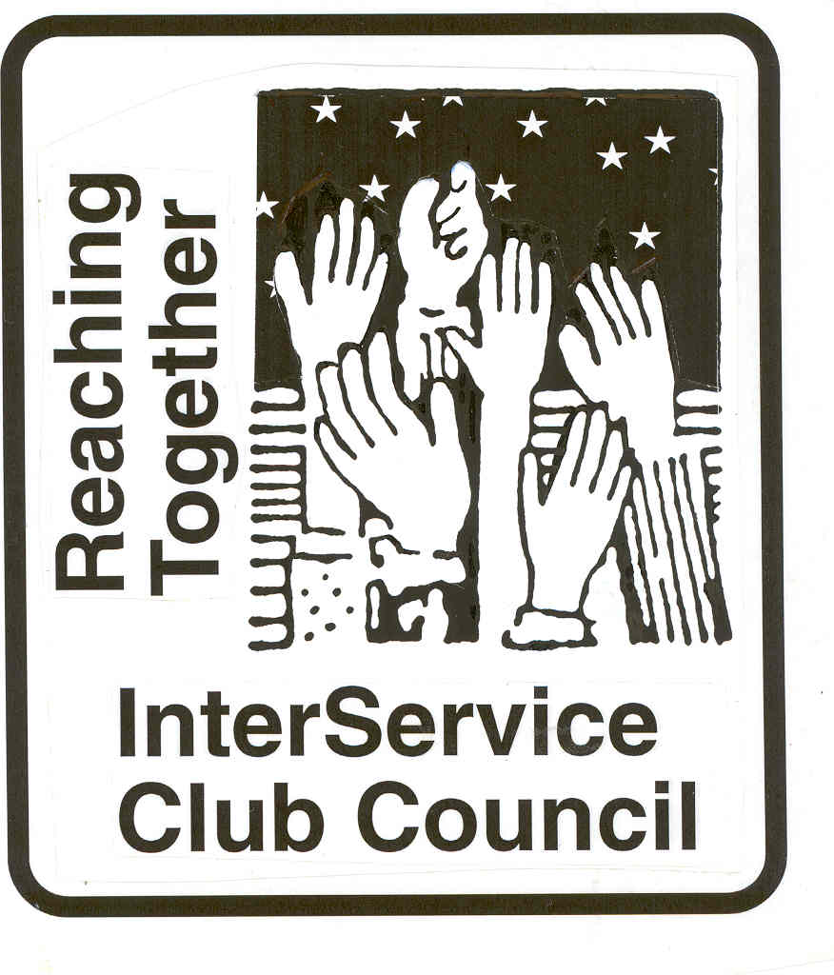

**iscc-fairfaxva.org**

Volume 47, Number 5 2 February 2022



***Next Meeting***:

Wednesday, 2 March2022

12:00 PM

Moose Lodge

**ISCC Minutes**

President Leightley called the Zoom meeting to order at 12:02 PM. 18 members were present and Hildie checked in. Camelia Topias was a guest and speaker. President Leightley gave the invocation, and all recited the Pledge of Allegiance.

OFFICER REPORTS

Minutes of the December meeting were approved as provided.

Vice President Grimsley was not present.

Treasurer’s report was approved as provided. Treasurer Lauther reported the 23 organizations have paid their dues.

Immediate Past President Larson had nothing to report.

President Leightley had nothing to report.

MS Topais gave a very informative presentation on cyber security, and provided links/contacts to resource in the City and with her firm to obtain more information.

There being no other business, Club representatives gave their reports.

The meeting was adjourned at 1:10 PM.

***City of Fairfax***

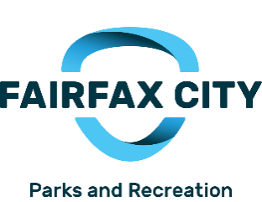

|  |  |
| --- | --- |
|  |  |

**Mayors’ Fitness Challenge**  
March 19 - May 7

Fairfax City, Town of Vienna and City of Falls Church are coming together to get citizens involved in a healthy competition to determine the “Most Fit City/Town” of 2022. During this 8-week competition, everyone will participate by keeping track of their minutes of physical activity, which will be tallied up at the end by each jurisdiction. Pre-registration is required, and you may register at any time during the competition. Join our Facebook event page to see and talk to others that are in the competition!  
Registration in now OPEN! [Mayors' Fitness Challenge (activecommunities.com)](https://apm.activecommunities.com/fairfaxcityrecdept/Activity_Search/14169)  
  
**Deanna Fix: deannafix@fairfaxva.gov**

**Mitzi Taylor** [**mitzi.taylor@fairfaxva.gov**](mailto:mitzi.taylor@fairfaxva.gov)**;**

 ***Chocolate Lovers Festival Committee (CLFC)***

Unfortunately, due to the spike in COVID-19 cases in the city and the region, the 2022 Chocolate Lovers Festival has been canceled. All of the vendors and volunteers involved in planning this unique event are extremely disappointed. We’re hopeful the public health situation next year will allow this fun midwinter celebration to resume.

Mitzi Taylor [Mitzi.taylor@fairfaxva.gov](mailto:Mitzi.taylor@fairfaxva.gov)

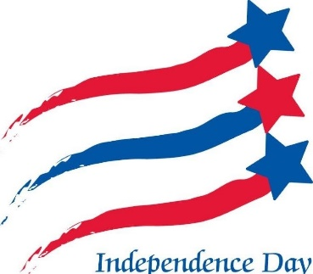

***Independence Day Celebration Committee (IDCC)***.  ***Independence Day Celebration Committee (IDCC***

Brenda Brichant [bbrichnat@gamil.com](mailto:bbrichnat@gamil.com)



The Central Fairfax Chamber of Commerce has a new home! We have relocated to the Willowood Plaza Office Park on Eaton Place. We reside in the Office Evolution space located at 10304 Eaton Place, Suite 100; Fairfax, VA 22030. This move comes in advance of the City's Economic Development Office's relocation to 10306 Eaton Place and the Mason Enterprise Center's relocation to 10300 Eaton Place. Willowood Plaza is about to become the "center of economic development" in the City of Fairfax!

We unveiled our new Tiered Dues Structure in January 2022. We believe businesses will find this to be a simpler, more affordable approach to setting membership dues. It offers more choices and flexibility for businesses than ever before! The new structure does not change the membership benefits or dues for nonprofit organizations. It's still only $175 for non-profits to join the Chamber.

Restaurant Week is just around the corner! The CFCC is once again partnering with the City of Fairfax's Economic Development Authority and Office to showcase and highlight our fantastic restaurant scene in the City. Restaurant Week will run from March 7 - 14 and will include more than 20 restaurants. Visit [www.fairfaxcityrestaurantweek.com](https://www.fairfaxcityrestaurantweek.com/) for more information.

Look for the Chamber at George Mason's Homecoming Tailgate on February 12 in the parking lot at EagleBank Arena!

For more information on the Central Fairfax Chamber of Commerce, visit [www.cfcc.org](http://www.cfcc.org)

**Jennifer Rose:** [**Jennifer@cfcc.org**](mailto:Jennifer@cfcc.org)

**Civitan Club of Fairfax**

Two of the teenagers who participated in the December 2021 three-day Leaders in Freedom Conference joined us in our January Civitan Club meeting to enthusiastically share with us their experiences.

Otherwise in January our Club leaders engaged in planning for the coming year, including arranging for a speaker at our 3 February Club meeting to tell us about the ENDependence Center of Northern Virginia. Also at the February meeting, we will hear about the Foundation for Children with Intellectual and Developmental Disabilities (FCIDD) and about its objectives and the processes for applying for financial support to benefit non-profit projects of worthy IDD-Related organizations. At this meeting ServiceSource will outline its latest project proposal to apply for FCIDD and Fairfax Civitan support.

During January, our Club “finished up” its fund raising from the sale of White House holiday ornaments. Our January service project continued, as our members bought many dozens of non-wool, non-white blankets for the children and others with development disabilities living in a boarding school in Africa.

**David Hartmann:**[**chartmann@cox.net**](mailto:chartmann@cox.net)

**Downtown Fairfax Coalition**

**Jim Wyckoff, Jr.: jcwyckoffjr@aol.com**

 **FAIRFAX FERNS GARDEN CLUB**

Christmas decorations were removed from Town Hall on Jan 10.

Nasrin Lescure, Mary Ann Barton and Kathy Hoffman met with Shane Flanigan from the county along with the plant designer, a  ember from FMD and Jean Schmidt from Frontier landscape services to go over the new landscape plans for the City of Fairfax Regional Library. Changes were proposed to the county design.  Planting will take place in the spring .

The next meeting of the Ferns is Feb 7 by zoom.

**Kathy Hoffman:** [Kathryn.j.hoffman@gmail.com](mailto:Kathryn.j.hoffman@gmail.com)

**Fairfax VA Harley**

**Owners Group**

**We have been busy getting organized with a new Director, Asst. Director, virtually planning activities for the year and putting on a number of training events.**

**Our plans for 2022 are ambitious in terms of meeting our mission of having fun riding, riding safely and giving some back to our community along the way. On February 12th, Chapter members will be giving the “Gift of Life” at INOVA Blood Center. As the year progresses, the Chapter will be active with our traditional charitable activities on behalf of the LAMB Center and the Salvation Army. There will be a few others along the way including Adopt-a-Spots in the City of Fairfax.**

**We are hopeful that our Chapter will proudly be hosting the 22nd Annual Ride of the Patriots on Sunday, May 29th. The current environment creates challenges, however, the FHOG Chapter, Patriot H-D and the City are favorable towards beginning to meet to see what might be possible. AmVets has yet to make any definitive statements on their plans for Rolling to Remember in D.C.. It is possible that we could host a smaller more local event that would not involve the Pentagon, but would include a parade, opening ceremonies and a motorcycle procession to an appropriate Military related venue that would recognize all those in uniform who have given life and limb in defense of our liberty and way of life. Any out-of-town riders would be welcome to join us.**

**Back in 2019 well over 5,700 bikes came to Fairfax to join our ride. Whatever we do and whoever attends, we look forward to a safe and memorable event in 2022. RoP has become a community Memorial Day weekend event with many residents and guests coming out to honor our military heroes.**

**We will also be participating in the City of Fairfax Independence Day Parade and will be conducting several Motorcycle “Show & Tell” Programs at County libraries and other venues throughout the summer, if they are held..**

**We look forward to working with the City and ISCC civic organizations in 2022 to make our community a better place for all of us.**

**The Fairfax Harley Owners Group is a diverse and energetic force of over 250 members. The Chapter publishes a monthly newsletter and maintains its own web page at** [**www.fairfaxhog.com**](http://www.fairfaxhog.com)

**Larry** **Larson: larry.d.larson@verizon.net**

**Fairfax City**

**Regional Library**

**City oFairfaxLibrary**

**10360 North Street**

**Fairfax, VA 22030**

703-293-6227 | TTY: 711

Sun.: 1 p.m. - 5 p.m.

Mon. - Thurs.: 10 a.m. - 9 p.m.

Fri.: 10 a.m. - 6 p.m.

Sat.: 10 a.m. – 5 p.m.

The City of Fairfax Regional Library offers a wide range of events for all ages, including children’s programs, ESL Conversation groups and tutoring, technology help, book discussions, genealogy and local history programs, and much more.

<http://www.fairfaxcounty.gov/library/events/>

The Friends are holding a Board Meeting next week to determine if we think we can hold a sale in April. Issues revolve around the number of people we can allow in the conference rooms we use and how to do crowd control without really ticking off the public. Covid has greatly decreased the capacity of the rooms.

On a happy note, our on-going sales continue to net us about $500 a month and we have had several very nice donations.

We continue to sort books every Tuesday starting at 10:00 a.m. in the conference rooms at the Fairfax Library. Any one who would like to join us is welcome and they must be able to show proof of vaccination. This is a new requirement of the library.

.**Katie Clary**: [kvclary@mindspring.com](mailto:kvclary@mindspring.com)

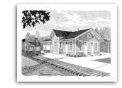

**Friends of**

**Fairfax Station**

**N Gauge (NTRAK) model trains will be on display and running at the Fairfax Station Railroad Museum on Sunday, February 20, 2022 from 1-4 p.m.  The Museum is located at 11200 Fairfax Station Road in Fairfax Station, VA. Admission:  Museum members and ages 4 and under, free; ages 5-12, $3; ages 13 and older, $5 ($6 for special events); seniors and military, active and retired, $4.** [**www.fairfax-station.org,**](http://www.fairfax-station.org,)[**www.facebook.com/FFXSRR,**](http://www.facebook.com/FFXSRR,) **703-425-9225.**

**Pete Conklin:** [**conklinps@aol.com**](mailto:conklinps@aol.com)



**John Keith: jkeith@bklawva.com**

**Kiwanis International**

**Kiwanis Club**

**of Fairfax**

Nothing to report.

**Mariann Gabor****mgabor2010@hotmail.com**

[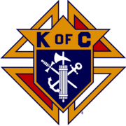](http://en.wikipedia.org/wiki/Image:Kofc.gif)

**Knights of Columbus**

**Father Diamond Council 6292**

The Council holds business meetings on the 2nd and 4th Tuesday’s of the month at 8 PM in Providence Hall at St Leo the Great Catholic Church. Web site**:** [**WWW.6292.kofc.com**](http://WWW.6292.kofc.com)**.** All meetings currently are hybrid (In person and virtual).

The council collected $15,700. during the Right to Life March to defray the cost of the March.

# February Activities:

- Feb 14 - Bingo at the Fairfax Nursing Center

- Feb 19 - Night of Magic Fund raiser at st LEO’s School Gym

= Feb 20 – Family Breakfast

**Albert Leightley:** [**Leightley8@verizon.net**](mailto:Leightley8@verizon.net)



January was a quiet month, no fund raising or service activity.  We held only two meetings - a regular meeting (by zoom), and a board meeting (by zoom).

Our speaker at the regular meeting, on January 18th, was financial planner John Wischum.  John reminded us to “pay yourself first” and stay disciplined to build an estate as we move across life toward retirement.

John suggested all should consider having: a Will, an Advance Medical Directive, a Durable Power of Attorney, and possibly a Revocable Living Trust.

He completed his talk in about 15-20 minutes, and he presents a useful service-club discussion.

His contact information:

John Wischum

24886 Dahlia Manor Place

Aldie, VA. 20105

888-432-0980

[John.wischum@prudential.com](mailto:John.wischum@prudential.com)

**Gordon Tillery:** [**tilleryg@gmail.com**](mailto:tilleryg@gmail.com)



**Centreville Moose Lodge #2168**

The Moose lodge hosted the Virginia's District 4 quarterly meeting on January 8. There were over 60 representatives from all Moose Lodges in the district in attendance. We provided breakfast and lunch for the attendees Our twice-annual Texas Holdem Tournament was held on January 15. We are looking forward to our annual Super Bowl Tailgate Party in the Social Quarters on February 13.

We will be holding Friday Night dinners: (February 4 - Steak or Haddock, February 11 – Chicken Parmesan (Valentines theme) February 18 – Grilled Ham Steak, and February 25 – the Moose Legion will provide an Open Faced Roast Beef dinner. We will continue to have Bingo and Queen of Hearts every Wednesday night, Tacos every Thursday night and free Texas Holdem games evert Tuesday evening and Sunday afternoon.

**Herb Zimmerman herb2777@yahoo.com**



CENTRAL FAIRFAX OPTIMIST CLUB

The Central Fairfax Optimist Club welcomed the New Year with happy and optimistic Optimists! Our active Club was undeterred by the weather, COVID concerns and other challenges: the challenges include meetings, fundraising, membership, and projects.

For any meeting, COVID, weather, and food are challenges. Anticipating bad weather and COVID concerns, we will conduct Zoom meetings in February. Since we have not been able to conduct our usual fundraising activities such as Trivia Night, we appealed to our membership to make a tax-deductible donation to our Youth Fund. While our Club is a 501(c4), we can accept a check payable to the Optimist International Foundation with the Memo line on the check noted “Fairfax Youth Fund 16026.” Optimist International then deposits that money into our Youth Fund Account for us to use for the kids.

It’s hard to recruit new members in this environment. But we do have a new potential member. What we offer anyone who joins our Club is the opportunity to make a difference in the life of a child. We are not expensive to join and Optimist International provides a $1 million insurance policy to cover our members while conducting community service.

We recently offered a $2,500 scholarship opportunity with our annual Essay Contest, but we had no applications. We are getting ready for our annual Oratorical Contest. Last year, one of our contestants became the Optimist International World Champion and amassed about $32,000 in scholarships.

The leaders of Optimist International, Lions and Rotary have agreed to encourage the members of each organization to come together to help the local community. For our Club, we would look forward to working with the Lions to help blind/vision impaired students.

The first Thursday in February is OPTIMIST DAY (this year 2/3/22). So be optimistic and do something positive for the community!

**Trinket Troy**  tearrific@aol.com



-We had a relatively slow month for January -We completed our distribution of copies of the Constitution to Fairfax 8th graders and dictionaries to 3rd graders. It went very well although complicated by Covid protocols.

-Our meetings will be staying Virtual until at least March 7th after which we hope to return in-person meetings at the Legion.

-We are also starting a planned restoration and development of our Float entry for the Independence Day parade.

-We have had some great speakers on community services (e.g. Lamb Center and Recovery Services) focusing on the homeless and other challenges facing members of our community.

-Sadly, we lost one of our members, John Swart, a lifetime resident of the City and a member of our club for almost 80 years. John was also a survivor of the D-Day invasion at Omaha Beach! John was the epitome of a life well lived.

All the best,

**Doug Church** douglaschurchjr@gmail.com



**Salvation Army**

**Women’s Auxiliary**

The Salvation Army Auxiliary met virtually in January. After much discussion, the group decided to not attempt a Fashion Show Fundraiser this Spring due to increase in Covid cases and the general age of our attendees.  Instead the Auxiliary will do a mail out donation campaign to our database.  The Corps has assisted Afghani refugee families with food, clothing, coats and personal care items.  In addition, vouchers to the  Thrift Shop have been distributed.  Plans for the month include a Winter Carnival for families on February 12.

**Connie Lauther:** [**lauthers2relo4u@cox.net**](mailto:lauthers2relo4u@cox.net)



**Sagan Brummett**

saganbrummett@**servicesource.org**



**Joe Meyer:** [**joe.meyer@shelterhouse.org**](mailto:joe.meyer@shelterhouse.org)



**Shepherd Center Fairfax Burke (SCFB)**

.

**Shepherd Center Fairfax Burke (SCFB)** SCFB is dedicated to helping older adults continue to live independently, and to providing enrichment and social networking

opportunities that keep life exciting and rewarding. Programs include Accompanied Medical Transportation and Companion Shopping (for older people who are no longer able to drive), Friendly Callers/ Visitors (for people who are mostly homebound), Caregivers Support Group (for those who have loved ones with dementia), low-cost exercise and yoga classes (to promote strength, balance and flexibility), and Lunch N’ Life, Adventures in Learning, and Wednesday at the Movies which all provide mental stimulation and socialization opportunities. For SCFB significant future and below activities see our web site [www.scfbva.org](http://www.scfbva.org).

DUE TO THE COVID RESTRICTIONS THE ONLY PROGRAMS CURRENTLY OPERATING ARE MEDICAL AND SHOPPING TRANSPORTATION IN BOTH FAIRFAX BURKE AND SOUTH COUNTY, CHAIR YOGA AND BOOK CLUB VIA ZOOM, FRIENDLY CALLER AND CARE GIVER PROGRAMS. AIL LUNCH N LIFE, FRIENDLY VISITOR, HANDY HELPER AND MOVIES ARE SUSPENDED UNTIL FURTHER NOTICE.

But Shepherd Center is still active, current activities,

1. Transportation Program –had 242 Medical and Shopping Drives by SCFB drivers during month.
2. Chair Yoga – SCFB Exercise Program conducted via Zoom, 3 times a week during the last month and average 59 participants per session.
3. Friendly Caller – made 100 contacts for the month.
4. Friendly Visitor – 7 during the month
5. Book Club - conducted two ZOOM meetings had 16 participants.
6. Handy Helper – Started up again and had 0 tasks for the month.
7. Held quarterly Board Meeting the 13 January

Volunteer Drivers and ride schedulers are critically needed. Please pass to your organizations. They can contact me at 703-273-2089 or [Leightley8@verizon.net](mailto:Leightley8@verizon.net) if interested

**Albert Leightley:** [***Leightley8@verizon.net***](mailto:Leightley8@verizon.net)

**Connie Lauther**

***Soroptimist International of Fairfax County***

We have selected our female head of household grant recipient and will present the check to her in the next few weeks..

**Cathy Kelleher: dandckelleher@cox.net­­­­­­­­­­­­­­­­­­­­­­­­­­­­­­­­­­­­­­­­­­­­­­­­­­­­­­­­­­­­**



**Woman’s Club of Fairfax**

Our club did not meet in January so it's been a quiet time for us, although plans for the future continue.  We usually have a potluck in-house fundraiser in February, but due to Covid, this has been postponed till March.  We will most likely meet by Zoom at our February meeting.

Our members are providing food for the Hypothermia Shelter to be held at the Fairfax Methodist Church on February 6.

**Suzanne Grimsley: suzanne.grimsley@yahoo.com**



Our service project for the spring will be continued support of the DVAC through monthly gift cards for stocking the grocery pantry. We look forward to monthly in-person grocery shopping when DVAC feels it is safe. During the holiday season the club donated Thanksgiving food baskets to families through Cornerstone in Reston and provided gift cards for DVAC families.

Advocacy is continuing at the international level with the Stop Child Marriage campaign. At the local level our advocacy effort is to encourage and have the Fairfax County Board of Supervisor pass a resolution supporting CEDAW. CEDAW (Convention on the Elimination of all Forms of Discrimination against Women) was adopted in 1979 by the UN General Assembly. It has been endorsed by 189 countries. The United States is one of the few countries that has not signed in support of the convention. A draft resolution is available. The League of Women Voters and other organizations like the Zonta Club of Fairfax would like other local clubs and organizations to comment on the resolution and to be supporters. If any club in the ISCC would like to review the document and/or support the effort, please email me and I will forward it to you. ([blanchewa@msn.com](mailto:blanchewa@msn.com)) The club is also looking for ways to support passage of the Equal Rights Amendment.

With the pandemic, several of our regular fundraising activities were cancelled. As more of the annual activities like Rock the Block start up again, the Zonta Club of Fairfax will again participate. The club continued the holiday wreath sales and our on-line fundraisers with Abby Candles and Boon Supply (these continue year-round).

The club will re-establish the NOVA Community College Scholarship this Spring. The scholarship will be promoted through scholarship websites, the ISCC newsletter and any other club newsletter, if a club offers to help.

Two major gatherings for Zontians in the first half of 2022 are the Area workshop on April 30th. It will likely be held both in person and virtually. Bobbie Cardillo, Area 4 Director and a member of our club, is working on the program. The Zonta International Convention, held every two years, is scheduled for June 25-28 in Hamburg, Germany. A couple of club members will attend in person and some will attend virtually.

**Blanche Anderson:** [blanchewa@msn.com](mailto:blanchewa@msn.com)