**Inter-Service Club Council of the City of Fairfax**

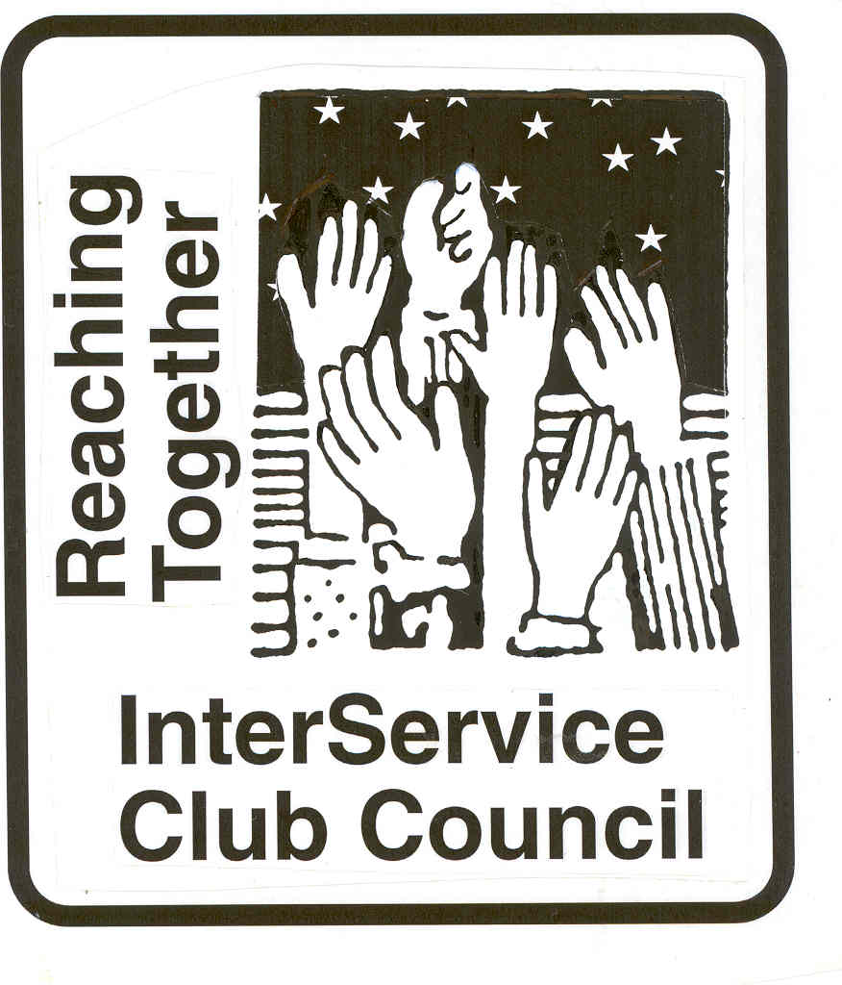

**iscc-fairfaxva.org**

Volume 47, Number 4 5 January 2022



***Next Meeting***:

Wednesday, 2 February 2022

12:00 PM

Moose Lodge

**ISCC Minutes**

President Leightley called the meeting at the Moose Lodge to order at 12:03 PM. Eighteen members were present. Lesley Abarchian of Fairfax City Government, and Janice Miller of the City Council were guests.

OFFICER REPORTS

Minutes of the November meeting were approved as provided.

Vice President Grimsley was not present.

Treasurers report was approved as provided. Treasurer Lauther reported that only 1 club had not paid their dues.

Immediate Past President Larson had nothing to report.

President Leightley reported that long time Historic Fairfax City Inc representative Hildie Carney is retiring from the HCFI Board, so no longer will represent HCFI on the ISCC. She will continue to attend meetings as she is able.

Lesley Abarchian, a Clinical Social Worker working for the City, spoke about the City’s new initiative to create a “Village” within the City to connect residents needing services with residents/organizations willing and able to provide those services. The concept has been tried successfully in several area jurisdictions. The process is still in the development stage, but they would like ISCC involvement on some level.

There was no New or Old Business.

Club gave their reports.

The Meeting was adjourned at 1:13 PM.

***City of Fairfax***



|  |  |
| --- | --- |
|  |  |

**Mitzi Taylor** [**mitzi.taylor@fairfaxva.gov**](mailto:mitzi.taylor@fairfaxva.gov)**;**

***Chocolate Lovers Festival Committee (CLFC)***.. ***Chocolate Lovers Festival Committee (CLFC)***

Mitzi Taylor [Mitzi.taylor@fairfaxva.gov](mailto:Mitzi.taylor@fairfaxva.gov)

***Independence Day Celebration Committee (IDCC)***.  ***Independence Day Celebration Committee (IDCC***

Brenda Brichant [bbrichnat@gamil.com](mailto:bbrichnat@gamil.com)



Have a wonderful holiday season!

**Jennifer Rose:** [**Jennifer@cfcc.org**](mailto:Jennifer@cfcc.org)

**Civitan Club of Fairfax**

Supporting Civitan’s motto, **“Builders of Good Citizenship,”** Fairfax Civitans and other Clubs in the Chesapeake District host an annual **Leaders in Freedom Conference** (LIF) in December for high school students in grades 10-12. This year’s LIF was held in person, December 3-5, 2021, at Camp Piankatank in Hartfield, VA. ).  LIF is a 3-day event for students interested in leadership and thinking out-side the box. It is a student led weekend of speakers and workshops with college professors, business owners, leaders, and entrepreneurs within their fields. The Conference is free to the students, with sponsorships provided by Civitan Clubs; for instance, our Fairfax Club sponsored four students (at $315 each). We do ask that students visit our Clubs and share their LIF experiences.

December was a busy month for Fairfax Civitan. Early in the month we participated in a Board meeting of the Foundation for Children with Intellectual and Development Disabilities. We “skipped” having a regular December Club meeting, but we much enjoyed a zoom “fun night” where we played Bingo, Family Feud, and other fun games. We did, mid-month, have a Civitan Club zoom Board meeting where we reported what we are doing and planned for the future. Our service project for the month was acquiring new toys (for tots), and we delivered hundreds of toys that members of our Club purchased to give away to needy children. Fund raising also continued, especially the sale of White House ornaments.

We hope to have several LIF students join us at our 6 January zoom Club meeting. Our service project in January is to acquire new, non-wool not white, twin size blankets to brighten the life a bit of special need children and others living in a boarding school in Africa. We already have gathered over thirty blankets, and we are just getting going.

**David Hartmann:**[**chartmann@cox.net**](mailto:chartmann@cox.net)

**Downtown Fairfax Coalition**

**Jim Wyckoff, Jr.: jcwyckoffjr@aol.com**

 **FAIRFAX FERNS GARDEN CLUB**

January 10, 2022 will undecorate Old Town Hall 6-7pm

February 7, 2022 General meeting at 6:30 pm at the City of Fairfax Library

**Kathy Hoffman:** [Kathryn.j.hoffman@gmail.com](mailto:Kathryn.j.hoffman@gmail.com)

**Fairfax VA Harley**

**Owners Group**

Unfortunately our first official ride of 2022, our Wind Chill Ride had to be cancelled due a sudden snowfall of six inches of wet, heavy snow. Things happen…..

The Chapter enthusiastically joined with many other groups and individuals in the Salvation Army’s 2021 Christmas Program. This year returned to a more traditional Christmas Stockings, Angel Tree, clothing, a few bikes and selected needs of each family. Families in need of help involving over 1,000 children were served by the Salvation Army.

On December 11 ten Chapter members provided time and effort to assemble bikes and other help as needed to get ready for the Christmas gift distribution.

On Dec.16 & 17, twelve Chapter Elves helped with traffic management along with the distribution of boxes of gifts to each family scheduled to receive them. The weather was mild and the arrivals were well scheduled so distribution went very smoothly. There were many happy faces of appreciation.

Our Chapter’s charitable activity generates financial support that is distributed to charities in five categories including; kids, community outreach, veterans, police-fire-rescue and critters. In addition, the Chapter has contributed a considerable amount of non-financial effort to several causes such as the Show & Tells, Adopt-a-Spots, Blood Drives, Officer Down and Healing Heroes, Jill’s House and the Lamb Center.

The Chapter has elected and appointed its slate of Officers for 2022. Jack Causa becomes Director. Planning of 2022 activities will be completed during January. In addition to organized rides and safety training, community support activities will be similar to 2021 with the hope that COVID related restrictions and precautions will subside and life can return to normal. Our annual Have a Heart Blood Drive at INOVA Fairfax is coming up on February 12th.

The Fairfax Harley Owners Group is a diverse and energetic force of 250 members. The Chapter publishes a monthly newsletter and maintains its own web page at [www.fairfaxhog.com](http://www.fairfaxhog.com/)

Happy New Year to All.

**Larry** **Larson: larry.d.larson@verizon.net**

**Fairfax City**

**Regional Library**

**City oFairfaxLibrary**

**10360 North Street**

**Fairfax, VA 22030**

703-293-6227 | TTY: 711

Sun.: 1 p.m. - 5 p.m.

Mon. - Thurs.: 10 a.m. - 9 p.m.

Fri.: 10 a.m. - 6 p.m.

Sat.: 10 a.m. – 5 p.m.

The City of Fairfax Regional Library offers a wide range of events for all ages, including children’s programs, ESL Conversation groups and tutoring, technology help, book discussions, genealogy and local history programs, and much more.

<http://www.fairfaxcounty.gov/library/events/>

.**Katie Clary**: [kvclary@mindspring.com](mailto:kvclary@mindspring.com)

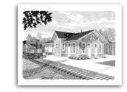

**Friends of**

**Fairfax Station**

**The Potomac Module Crew will display and run HO Scale Model trains at the Fairfax Station Railroad Museum on Saturday, January 22, 2022 from 12-4 p.m. and on Sunday, January 23 from 1-4 p.m.  The Museum is located at 11200 Fairfax Station Road in Fairfax Station, VA.  Admission:  Museum members and ages 4 and under, free; ages 5-12, $3; ages 13 and older, $5, special events, $6; seniors and military, active and retired, $4.**

**Pete Conklin:** [**conklinps@aol.com**](mailto:conklinps@aol.com)



**Hildie Carney:** [**hilcarn31@aol.com**](mailto:hilcarn31@aol.com)

**Kiwanis International**

**Kiwanis Club**

**of Fairfax**

The club will be doing Meals for Young Minds and preparing for the chocolate lover's festival.

**Mariann Gabor****mgabor2010@hotmail.com**

[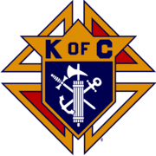](http://en.wikipedia.org/wiki/Image:Kofc.gif)

**Knights of Columbus**

**Father Diamond Council 6292**

The Council holds business meetings on the 2nd and 4th Tuesday’s of the month at 8 PM in Providence Hall at St Leo the Great Catholic Church. Web site**:** [**WWW.6292.kofc.com**](http://WWW.6292.kofc.com)**.** All meetings currently are hybrid (In person and virtual).

Annual Christmas Tree Sales completed two weeks before Christmas and were sold out. The council netted $9,427 with 405 trees sold.. Thanks for those who bought trees this year.

# January Activities:

* 8 January Quarterly State meeting Fredericksburg
* 16 January Family Breakfast after 7:30 and 9 AM Masses
* 18 January Gray Gost Luncheon
* 21 January March for life
* 29 January KOVAR charity pot pie sales

**Albert Leightley:** [**Leightley8@verizon.net**](mailto:Leightley8@verizon.net)



On Dec 20, Fairfax Lions delivered 30 holiday food baskets to help our community neighbors with basic food needs.  We deliver the food baskets to our partner, Main Street Child Development Center, who selects families in need and provides a venue for the families to pick-up the food baskets.

**Lions Peace Poster Contest Winner**

*We c*ongratulate Audrey Nagle for her winning Peace Poster.  Audrey is an 8th grade student at Rocky Run Middle School.  Her Peace Poster is shown below.

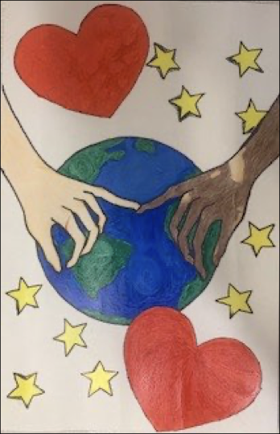

Audrey’s quote: “Peace is what keeps us all connected; it also keeps us sane.”  Fairfax Lions will recognize Audrey at an upcoming dinner meeting, and her poster has advanced to the next level competition in the international Peace Poster Contest.  For over three decades, Lions clubs around the globe have sponsored this very special art contest in schools and youth groups.  Creating peace posters gives children everywhere the chance to express their visions of peace and inspire the world through art and creativity.

**December Citrus Fruit Sale**

We were pleasantly surprised by 50-60 degree days and enjoyed SUCCESS in charity fund raising at our December 16-18 fruit sale.  The next sale in March 10-12, 2022.  We thank all our customers for supporting Lions Charity Fund raising by buying fruit!!!

**Gordon Tillery:** [**tilleryg@gmail.com**](mailto:tilleryg@gmail.com)



**Centreville Moose Lodge #2168**

The Centreville Moose Lodge had a wonderful Christmas season with many members participating in our Holiday giving spirit.  Through the annual Angel Tree we were able to provide new sheets, blankets, toiletries, personal hygiene items, special gifts of food, candy and baked goods along with hundreds of dollars in support of the Robinson House half-way Center.  Santa visited with 15 of our members children and Grandchildren bringing them each a special gift.  He joined them in arts and crafts and everyone had a wonderful time.

This year's annual Holiday giving included cash donations to Mooseheart, Moosehaven, the 29 Diner GoFundMe campaign, Valued Veterans Kids Camp, Special Olympics, VetsHouse, Inc., Old Dominion Home, Virginia Moose Association's Youth Awareness Program and Moose International's Safe Surfin Program.

We are looking forward to 2022 when we will be the host Lodge for Virginia's District 4 quarterly meeting on January 8 and our Texas Holdem Tournament on January 15.  We will be holding Friday Night dinners: (January 7 - Steak or Haddock, January 14 - Beef Stroganoff, January 21 - Fish and Shrimp Fry, and January 28 - Roasted Chicken). We will continue to have Bingo and Queen of Hearts every Wednesday night, Tacos every Thursday night and free Texas Holdem games evert Tuesday evening and Sunday afternoon.

**Herb Zimmerman herb2777@yahoo.com**



CENTRAL FAIRFAX OPTIMIST CLUB

December was another busy month for the Central Fairfax Optimist Club. We began with Christmas bell ringing for the Salvation Army at the Burke Walmart. The Walmart customers were not only generous with their donations for the kettle, but also with their support of our Club’s toy drive for the children in the INOVA Hospital Childhood Cancer Ward.

At our annual holiday social, we collected character band-aids and toys for kids at the INOVA Fairfax hospital childhood cancer ward and can pull tabs for the Ronald McDonald house.

On December 16th there was a Christmas Party held at Mountain View High School for the students of Project Opportunity.  This is a group of students at the school who are parents of children, and our Optimist Club contributes gifts to these children each year.  Thanks to the generous monetary donations from our members, Trinket Troy and Anne Grabowski purchased books and outfits for each one of the 25 young children and were given to their parents.  Project Opportunity gives support to these students, provides diapers and other baby items, and runs a food closet for them.  It is a very successful program and extremely appreciated by the students because it helps them to continue with their education and provides help for them to succeed once they have graduated.

The Central Fairfax Optimist Club had been very supportive of this program and we will hopefully be able to continue our involvement for many years to come.  This is another way we contribute to the success of our Youth in the community.

**Dee Rushforth** deerush4th@aol.com



**Jennifer Rose**: [Jennifer@cfcc.org](mailto:Jennifer@cfcc.org)



**Salvation Army**

**Women’s Auxiliary**

The Salvation Army Auxiliary had a busy December helping the Fairfax Corps with the holiday assistance program.  They sorted stockings for food/candy and organized the family care boxes  In addition they presented the Corps with a check for $990 as their members contribution to the Kettle Fund.  The Salvation Army with the generosity of our neighbors was able to assist over 400 local families with holiday assistance and over 875 children with toys and clothing.  Santa's workshop (the Corps Gym) was an incredible success.

The Auxiliary will meet in January to explore the possibility of continuing the many year tradition  of a Fashion Show, Luncheon with a Silent  Auction to raise money for the Fairfax Corps.

**Connie Lauther:** [**lauthers2relo4u@cox.net**](mailto:lauthers2relo4u@cox.net)



**Sagan Brummett**

saganbrummett@**servicesource.org**



**Joe Meyer:** [**joe.meyer@shelterhouse.org**](mailto:joe.meyer@shelterhouse.org)



**Shepherd Center Fairfax Burke (SCFB)**

.

**Shepherd Center Fairfax Burke (SCFB)** SCFB is dedicated to helping older adults continue to live independently, and to providing enrichment and social networking

opportunities that keep life exciting and rewarding. Programs include Accompanied Medical Transportation and Companion Shopping (for older people who are no longer able to drive), Friendly Callers/ Visitors (for people who are mostly homebound), Caregivers Support Group (for those who have loved ones with dementia), low-cost exercise and yoga classes (to promote strength, balance and flexibility), and Lunch N’ Life, Adventures in Learning, and Wednesday at the Movies which all provide mental stimulation and socialization opportunities. For SCFB significant future and below activities see our web site [www.scfbva.org](http://www.scfbva.org).

DUE TO THE COVID RESTRICTIONS THE ONLY PROGRAMS CURRENTLY OPERATING ARE MEDICAL AND SHOPPING TRANSPORTATION IN BOTH FAIRFAX BURKE AND SOUTH COUNTY, CHAIR YOGA AND BOOK CLUB VIA ZOOM, FRIENDLY CALLER AND CARE GIVER PROGRAMS. AIL LUNCH N LIFE, FRIENDLY VISITOR, HANDY HELPER AND MOVIES ARE SUSPENDED UNTIL FURTHER NOTICE.

But Shepherd Center is still active, current activities,

1. Transportation Program –had 299 Medical and Shopping Drives by SCFB drivers during month.
2. Chair Yoga – SCFB Exercise Program conducted via Zoom, 3 times a week during the last month and average 59 participants per session.
3. Friendly Caller – made 101 contacts for the month.
4. Friendly Visitor – 11 during the month
5. Book Club - conducted two ZOOM meetings had 16 participants.
6. Handy Helper – Started up again and had 0 tasks for the month.
7. Held quarterly Board Meeting.

**Albert Leightley:** [***Leightley8@verizon.net***](mailto:Leightley8@verizon.net)

**Connie Lauther**

***Soroptimist International of Fairfax County***

Finalizing our grants**.**

**Cathy Kelleher: dandckelleher@cox.net­­­­­­­­­­­­­­­­­­­­­­­­­­­­­­­­­­­­­­­­­­­­­­­­­­­­­­­­­­­­**



**Woman’s Club of Fairfax**

Winding up the year, we had a mostly social meeting in December, and were entertained by the Fairfax City High School Jazz Band.  We said good-bye to a couple of members who are moving away from the area.

Members donated over 231 hats, scarves, gloves and mittens and other winter items for Afghan refugees. We collected the items when members volunteered at the City of Fairfax Christmas Band concerts.  The project grew larger after the two concerts, and a collection box was placed at City Hall for further donations.

Our club president, Kim Luckabaugh, transported the box to Luthern Services, for distribution to Afghan refugees.

In February our club will be in charge of a Hypothermia Dinner held at the Fairfax Methodist Church.  Members will donate, prepare and serve food to those who need it.

Happy New Year to all of you!  May 2022 be a better year.

**Suzanne Grimsley: suzanne.grimsley@yahoo.com**



**Blanche Anderson:** [blanchewa@msn.com](mailto:blanchewa@msn.com)