**Inter-Service Club Council of the City of Fairfax**

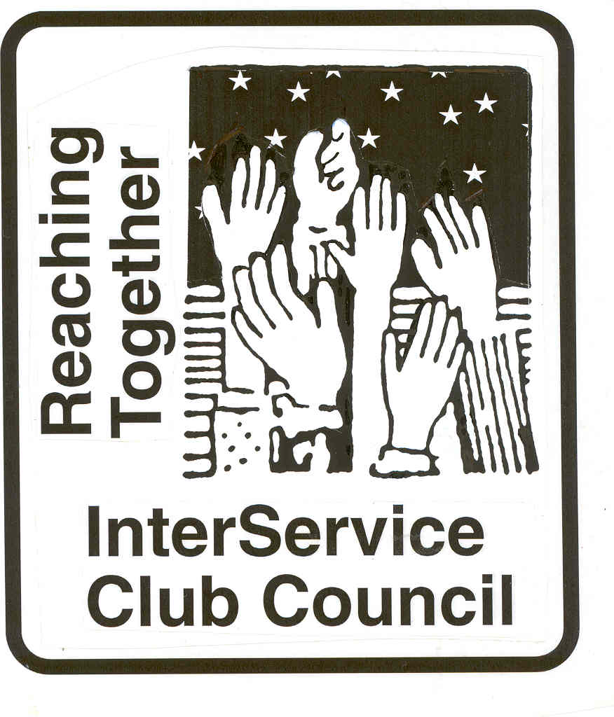

**iscc-fairfaxva.org**

Volume 47, Number 6 2 March 2022



***Next Meeting***:

Wednesday, 6 April 2022

12:00 PM

Moose Lodge

**ISCC Minutes**

President Leightley called the Zoom meeting to order at 12:02 PM. 18 Individuals participated. Gordon Tilery gave the invocation and all recited the Pledge of Allegiance.

Hildie Carney informed the group that several Fairfax City properties are featured during Garden Week starting 26 April 2022 She also informed us that she has been named manager of the Kitty Poser Garden.

OFFICER REPORTS

Minutes of the January meeting were approved as provided.

Vice President Grimsley announced that she is trying to get VDOT to speak next meeting on the Route 66 project.

The treasurer’s Report will be provided.

Immediate Past President Larson informed the group that the Harley Owners Group is planning to do a scaled back version of the Ride of the Patriots In May if circumstances allow.

President Leightley announced that the March meeting will be held in person at the Moose Lodge.

There being no Business, members gave club reports.

The meeting was adjourned at 12:54 PM.

.

***City of Fairfax***



|  |  |
| --- | --- |
|  | **Upcoming Events:**  **Mayors’ Fitness Challenge**  **(March 19-May 7)–** Here is an  egg-streme challenge: Finding eggs in the dark!  Fun for kids 10-14 yr old.  Register here:  [Mayors' Fitness Challenge (activecommunities.com)](https://apm.activecommunities.com/fairfaxcityrecdept/Activity_Search/14169)  **Egg-streme Teen Egg Hunt (April 7)–**  Here is an egg-streme challenge:  Finding eggs in the dark! Fun for kids 10-14 yr old.  **Chocolate Lover Festival**  Logo, company name  Description automatically generated  The Chocolate Lovers Festival Committee  grant is awarded to a non-profit organization(s) in the  City of Fairfax, or a non-profit organization in the metropolitan Washington area that provides services directly to people who  live in the City of Fairfax.  We seek organizations that contribute  to the common good and the community at large. The 3 winners  this year are:   1. SafeSpot Children’s Advocacy Center 2. of Fairfax 3. Opportunities Alternatives and 4. Resources (OAR) 5. Regratifying Foundation |

Mitzi Taylor [Mitzi.taylor@fairfaxva.gov](mailto:Mitzi.taylor@fairfaxva.gov)



***Independence Day Celebration Committee (IDCC)***.  ***Independence Day Celebration Committee (IDCC***

Brenda Brichant [bbrichnat@gamil.com](mailto:bbrichnat@gamil.com)



Things are REALLY heating up at the Central Fairfax Chamber of Commerce! We have had an influx of new members in January and February! Our networking events are becoming more lively as well. Restaurant Week starts on March 7 with nearly 25 restaurants participating! Restaurant Week is a partnership with the City of Fairfax Economic Development Authority and the Chamber. In its 5th year, it is becoming a very popular and highly anticipated event in the City. Make sure you "Take a Bite Out of the City of Fairfax". We have an amazing variety of cuisine in a number of independently owned restaurants throughout the City.

In other news,  we are once again participating in Fairfax County Board Supervisor Pat Herrity's Teen Job Fairs. He is hosting two events this year on March 12 and 19. The event is free for employers who hire teens and its free for the job seekers.

As we look to the spring, we will continue to offer outstanding networking opportunities that will showcase our outstanding restaurants. We will once again be supporting the Old Town Fairfax Business Association's Asian Festival on Main that will take place in May. Would love to have your support on the event.

**Jennifer Rose:** [**Jennifer@cfcc.org**](mailto:Jennifer@cfcc.org)

**Civitan Club of Fairfax**

February was a busy month for Fairfax Civitans. Besides our speaker about the ENDependence Center of Northern Virginia, we, at our 3 February Club meeting, heard about the possibilities and processes for seeking project funding from the Foundation for Children with Intellectual and Developmental Disabilities (FCIDD). We also were updated about an actual project funding proposal from ServiceSource, and our Club endorsed, sponsored, and assisted in getting the proposal submitted to the FCIDD.

On 17 February, the Fairfax Civitan Board of Directors “met” via zoom and discussed, made decisions, or developed recommendations about a number of projects and proposals. We also heard reports about our successful white house ornament fund raiser and about our gathering of over 60 blankets for a boarding school in Kenya for children with special needs. Further, the Board agreed to proceed with funding a number of worthy organizations.

Our 3 March zoom Club meeting will feature a presentation about the Joey Pizzano Memorial Fund. Then we will take some time to greet, initiate, and introduce two new Club members. This also is a time to talk about what Civitan is and does and why we care.

**David Hartmann:**[**chartmann@cox.net**](mailto:chartmann@cox.net)

**Downtown Fairfax Coalition**

**Jim Wyckoff, Jr.: jcwyckoffjr@aol.com**

 **FAIRFAX FERNS GARDEN CLUB**

Virginia Garden Week is the last week in April .  Fairfax Historic Garden Day  is Tuesday April 26,2022 from 10-4pm. . A number of sites in the City will be featured. THe Fairfax Ferns will be docents for the Kitty Pozer Garden next to the Ratcliff- Allison House. We need volunteers for this so if anyone is interested in learning about the garden and being a docent  please contact  Hildie. If you choose a shift you will get a free ticket for the rest of the tour.

 Items needed:

        1) being a docent on Tuesday April 26 --

        2) Beginning March 15th (weather permitting) helping to "shape up" the KP garden

The Ratcliff-Allison-Pozer House will be open for viewing beginning at 10AM.  The tour will start at the front door

on Main Street and end at the back door leading into the Garden.  Karin or Hildie will be in the house to show the

participants the original Kitty garden plan and the current plan to orient the visitors.  They will then be met by a docent

who will be available to answer questions and take them thru the garden.

There will be 2 shifts - from 10:30 to 1PM and 1PM to 4PM  --need 2 or 3 people per shift.

Please let me know if you can participate and thank you for your interest.

Hildie

703 591 5305 -703 927 7061 or [hilcarn31@aol.com](mailto:hilcarn31@aol.com)

Good news:  if you choose a shift, you will get a free ticket to use for the tour to other locations including 2 beautiful homes.

**Kathy Hoffman:** [Kathryn.j.hoffman@gmail.com](mailto:Kathryn.j.hoffman@gmail.com)

**Fairfax VA Harley**

**Owners Group**

# Fairfax Harley Owners Group

We are eagerly anticipating the “official” opening ride, an annual favorite, the No Blarney Ride on March 19th We are eagerly looking forward to a busy 2022 riding season and the activities promoting the enjoyment of motorcycling, safe riding and community involvement.

On Saturday, February 12th the Chapter sponsored our annual Have-A-Heart Blood Drive at INOVA-Woodburn. These gifts are precious and critical to those requiring surgery, accident victims and newborns. Bad weather depressed turnout so we will redo the event at a later date.

The Chapter will be supporting Patriot H-D on April 2nd to clean up their Adopted Spot of Fairfax Blvd. from Patriot H-D, West to the Fire Station and also in front of City Hall on Armstrong Street. We are joining many other groups and citizens of Fairfax City to spruce up the community we all take pride in.

We are very pleased and excited to announce that work is well underway on our 22nd annual “Ride of the Patriots” event on Sunday, May 29th. The ride this year will join “Rolling to Remember” at RFK. No doubt these two events will be smaller event than in 2019, but the purpose is the same. We believe it is important to honor and remember all those in uniform who have given their lives or are missing in action while protecting our liberty. This event will include the same elements, a Community Parade and Opening Ceremonies that attracts local leaders, neighbors and veterans. Each year we are overwhelmed by the large numbers of residents who come to share in what has become a terrific Community event. Everyone is invited to honor those who serve so unselfishly. Stay tuned for more details.

We look forward to working with the City and ISCC civic organizations in 2022 to make our community a better place for all of us.

The Fairfax Harley Owners Group is a diverse and energetic force of over 300 members. The Chapter publishes a monthly newsletter and maintains its own web page, [www.fairfaxhog.com](http://www.fairfaxhog.com/)

**Larry** **Larson: larry.d.larson@verizon.net**

**Fairfax City**

**Regional Library**

**City oFairfaxLibrary**

**10360 North Street**

**Fairfax, VA 22030**

703-293-6227 | TTY: 711

Sun.: 1 p.m. - 5 p.m.

Mon. - Thurs.: 10 a.m. - 9 p.m.

Fri.: 10 a.m. - 6 p.m.

Sat.: 10 a.m. – 5 p.m.

The City of Fairfax Regional Library offers a wide range of events for all ages, including children’s programs, ESL Conversation groups and tutoring, technology help, book discussions, genealogy and local history programs, and much more.

<http://www.fairfaxcounty.gov/library/events/>

Friends of the Fairfax City Library has voted not to have a Children’s  Book Sale this year. We are selling so many Children’s books at our on-going sale that we do not have a backlog. We will have a big book sale in April. We will set-up April 18-20. The sale to the general public will be April 22-24 with the bag sale on the 24th at $8 a bag. On Thursday the 21st we will be trying something new. We will be having a preview sale in 2 hour increments. People coming to this sale will have to pre-register and pay $30 for the privilege of this early sale. We hope to attract the dealers and make a little more money although anyone can pre-register for this sale.

.

.**Katie Clary**: [kvclary@mindspring.com](mailto:kvclary@mindspring.com)

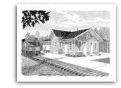

**Friends of**

**Fairfax Station**

Annual Membership meeting March 16.

N-TRAK trains running March 20.

**Pete Conklin:** [**conklinps@aol.com**](mailto:conklinps@aol.com)



**John Keith: jkeith@bklawva.com**

**Kiwanis International**

**Kiwanis Club**

**of Fairfax**

Nothing to report.

**Mariann Gabor****mgabor2010@hotmail.com**

[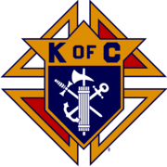](http://en.wikipedia.org/wiki/Image:Kofc.gif)

**Knights of Columbus**

**Father Diamond Council 6292**

The Council holds business meetings on the 2nd and 4th Tuesday’s of the month at 8 PM in Providence Hall at St Leo the Great Catholic Church. Web site**:** [**WWW.6292.kofc.com**](http://WWW.6292.kofc.com)**.** All meetings currently are hybrid (In person and virtual).

# March Activities:

- Mar. 5 – Host State Quarterly Meeting

- Mar12 – Council Men’s Retreat

- Mar 13 – Family Breakfast after 7:30 and 9 AM Masses

* Mar 19 – Council St Patrick’s party
* Mar 31 to Apr 3rd KOVAR Collections

**Albert Leightley:** [**Leightley8@verizon.net**](mailto:Leightley8@verizon.net)



At our Feb 22 meeting, the Club authorized disbursements to the following charities (all part of our annual budget for various charity endeavors). Click names to know more.

* $1000 to [Sprout Therapeutic Riding Center](https://sproutcenter.org)
* $1000 to [Fairfax Little League](https://www.fairfaxll.org)
* $1000 to [Lamb Center](https://www.thelambcenter.org)
* $500 to [Lions Youth Camp](https://stauntonlionsclub.org/YouthCamp)

For several reasons, including the questionable quality of fruit (due to “[Citrus Greening](https://www.aphis.usda.gov/aphis/resources/pests-diseases/hungry-pests/the-threat/citrus-greening/citrus-greening-hp)”) we canceled our planned fruit sale in March.  We initiated a review of future fruit sales to look fruit sources, customer base, and working with other clubs to expand the reach of our sales.

We were pleased to see the City of Fairfax Senior Center newsletter mentioned our club with these words:



See that newsletter at, [FX Senior Center Newsletter: Jan 2022- Apr 2022](https://www.fairfaxva.gov/home/showpublisheddocument/18823/637793119315670000)

**Gordon Tillery:** [**tilleryg@gmail.com**](mailto:tilleryg@gmail.com)



**Centreville Moose Lodge #2168**

**Herb Zimmerman herb2777@yahoo.com**



CENTRAL FAIRFAX OPTIMIST CLUB

The Optimist Club held the February meeting by ZOOM due to weather related issues and COVID concerns. Our speaker was Evelyn Clumpkens, counselor at Mountain View High School.

She spoke about Project Opportunity which is a program for students who are parents and other programs they have for their students.  Most of the students work to help support their families; some are the only English speaking person in the family.

The staff is very supportive of the students and tries to make it more like a family-type atmosphere.

The Optimist Club is gearing up for the Oratorical Contest in March which  will be held by ZOOM.  We have 13 contestants

Unfortunately, we did not have any applicants for our Essay Contest.

Our Club is run by two vice presidents this year as we did not have a President. We are happy to report that we have volunteer for ' next year's President for our Club for the April elections...Claudia Pellegrino!

**Trinket Troy**  tearrific@aol.com



**Doug Church** douglaschurchjr@gmail.com



**Salvation Army**

**Women’s Auxiliary**

**Connie Lauther:** [**lauthers2relo4u@cox.net**](mailto:lauthers2relo4u@cox.net)



ServiceSource Virginia has had a busy February!

ServiceSource Virginia recently received the Safeway foundation grant. This grant will help support the Autism Services Program.

ServiceSource has partnered with The Mclean Project for the Arts, with their Art Reach program. This program provides weekly online classes and offers a way to cross the digital divide and provides hands on, virtual activities. This partnership was first established in 2020. The program, and ServiceSource involvement was recently highlighted I the MPA, (McLean Project for the Arts), newsletter.

The Bloom Artisans, having partnered with Seniors in Service, are continuing to create handmade cards to send to veterans experiencing isolation and hardships, due to Covid and other health and safety concerns. The Artisans create the cards, and the seniors write encouraging messages in each card and send to the veterans. To date, more than 600 cards have been sent. This collaboration melds two service areas, across two states, Virginia, and Florida. For more information or to order cards, please email [bloom@servicesource.org](mailto:bloom@servicesource.org)

The Fairfax County Board of Supervisors unanimously approved a special use exception for ServiceSource Virginia to operate the Elmore Farmhouse at Frying Pan Park. This will offer another in-community program for the Long-Term Community Integration Services program, (LTCIS). This will allow services to be provided for participants in a community setting, letting them give back to their community.

The ServiceSource virtual activities program was in full swing during the month of February. Virtual activities were offered at all ServiceSource sites across the organization. Activities offered included exercise, dance, and yoga classes, art projects, virtual cooking classes, and virtual travel. Virtual sensory integration activities were also provided. During the month of February ServiceSource presented weekly Black History Month presentations. There were also two guest speakers. Pastor Michelle Thomas of The Freedom Center spoke virtually to the group about the history of the Freedom Center and Black History in Virginia. Officer Hawkins of the Fairfax County Police spoke virtually about Personal Safety.

The Wellness Center for Older Adults, (WCOA) will have a soft opening on March 14th, 2022, with a ribbon cutting ceremony occurring later in the Spring. The WCOA is a program designed for older adults within a community setting. Through our numerous partnering agencies, services provided will include: An assistive technology lab, Center on Aging, exercise room, health screenings, recreational activities, and support groups. Community members are encouraged to come in and take advantage of all the services we will provide. Please see the attached flyer for more information.

**Sagan Brummett**

saganbrummett@**servicesource.org**



**Joe Meyer:** [**joe.meyer@shelterhouse.org**](mailto:joe.meyer@shelterhouse.org)



**Shepherd Center Fairfax Burke (SCFB)**

.

**Shepherd Center Fairfax Burke (SCFB)** SCFB is dedicated to helping older adults continue to live independently, and to providing enrichment and social networking

opportunities that keep life exciting and rewarding. Programs include Accompanied Medical Transportation and Companion Shopping (for older people who are no longer able to drive), Friendly Callers/ Visitors (for people who are mostly homebound), Caregivers Support Group (for those who have loved ones with dementia), low-cost exercise and yoga classes (to promote strength, balance and flexibility), and Lunch N’ Life, Adventures in Learning, and Wednesday at the Movies which all provide mental stimulation and socialization opportunities. For SCFB significant future and below activities see our web site [www.scfbva.org](http://www.scfbva.org).

DUE TO THE COVID RESTRICTIONS THE ONLY PROGRAMS CURRENTLY OPERATING ARE MEDICAL AND SHOPPING TRANSPORTATION IN BOTH FAIRFAX BURKE AND SOUTH COUNTY, CHAIR YOGA AND BOOK CLUB VIA ZOOM, FRIENDLY CALLER AND CARE GIVER PROGRAMS. AIL LUNCH N LIFE, FRIENDLY VISITOR, HANDY HELPER AND MOVIES ARE SUSPENDED UNTIL FURTHER NOTICE.

January Activities:

1. Transportation Program –had 242 Medical and Shopping Drives by SCFB drivers during month.
2. Chair Yoga – SCFB Exercise Program conducted via Zoom, 3 times a week during the last month and average 64 participants per session.
3. Friendly Caller – made 92 contacts for the month.
4. Friendly Visitor – 8 during the month
5. Book Club - conducted two ZOOM meetings had 16 participants.
6. Held Virtual Meeting with Council of Representatives on 10 Feb.

Volunteer Drivers and ride schedulers are critically needed. Please pass to your organizations. They can contact me at 703-273-2089 or [Leightley8@verizon.net](mailto:Leightley8@verizon.net) if interested.

**Albert Leightley:** [***Leightley8@verizon.net***](mailto:Leightley8@verizon.net)

**Connie Lauther**

***Soroptimist International of Fairfax County***

Sent donations to Second Story, Bethany House, and our Woman Head of Household grant recipient. Looking into the possibility of having an outdoor Awards event in the summer, as our annual event has been canceled the last two years.

**Cathy Kelleher: dandckelleher@cox.net­­­­­­­­­­­­­­­­­­­­­­­­­­­­­­­­­­­­­­­­­­­­­­­­­­­­­­­­­­­­**



**Woman’s Club of Fairfax**

.

The Woman's Club bundled over 15,000 masks for distribution and use at Fairfax non-profits.

Members donated over 230 winter accessories through our partnership with the Fairfax City Band Association and Lutheran Services.

We made and distributed Valentine's appreciation cards to area food pantry workers.  Some members also made and distributed Valentine's cards to residents of Braddock Glen Assisted Living.

Members are still collecting plastic bottle caps for the "Make A Bench" project by Fairfax United Methodist Church preschoolers. To date we have collected 1500 caps.

Our scholarship application process for 2022 has begun; information is on our Facebook website.

Plans are in the works for our Fashion Show Scholarship Fundraiser.

Members will be volunteering to hand out tickets and act as ushers, etc., at three upcoming Fairfax City Band concerts.

**Suzanne Grimsley: suzanne.grimsley@yahoo.com**



**Blanche Anderson:** [blanchewa@msn.com](mailto:blanchewa@msn.com)