**Inter-Service Club Council of the City of Fairfax**

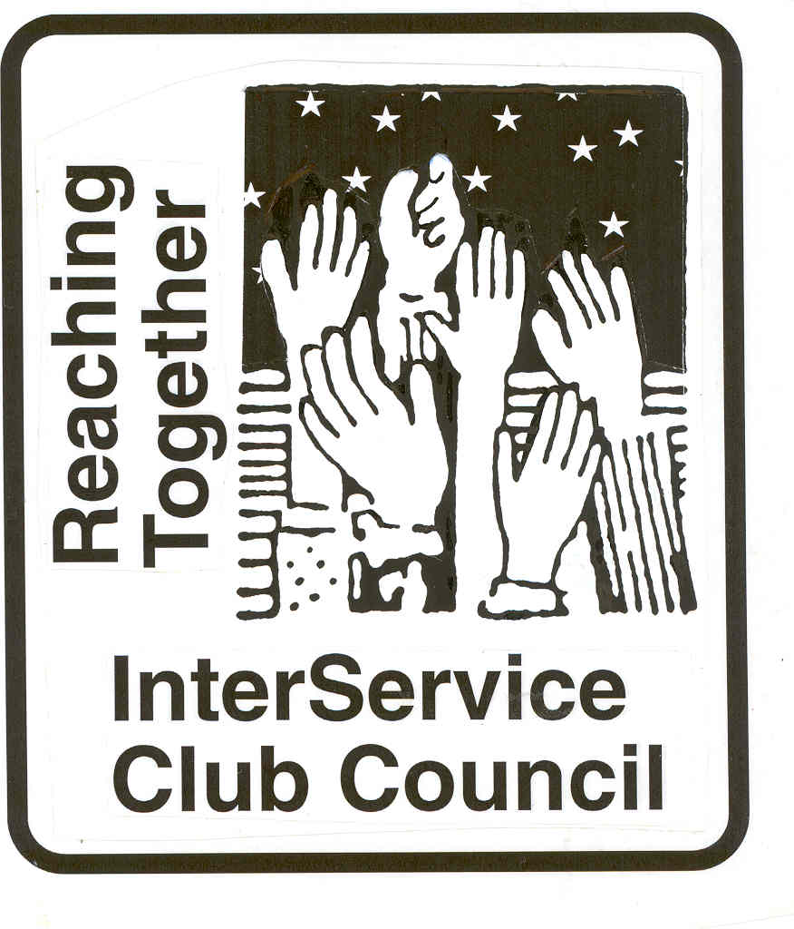

**iscc-fairfaxva.org**

Volume 47, Number 8 4 May 2022



***Next Meeting***:

Wednesday, 1 June 2022

12:00 PM

Moose Lodge

**ISCC Minutes**

President Leightley called the meeting to order at 12:04 PM. Forteen individuals representing 15 organizations were present. Gordon Tillery gave the invocation and all recited the Pledge of Allegiance. Alison Padger of Food for Others was a guest and speaker.

OFFICER REPORTS

Minutes of the March meeting were approved as provided.

Vice President Grimsley had nothing to report.

Treasurers Report was approved as provided.

Immediate Past President Larson deferred to Old Business.

President Leightley had nothing to report.

Alison Padger spoke about the mission of Food for Others. Amazingly, over 80,000 are food insecure in the Fairfax/Loudon/Prince William area. Most clients are working. Food for Others provides groceries, and weekend pack for children. Stores contribute near shelf life expiration groceries, Food for Others purchase produce, milk and eggs. In addition to donations, Ms Padget encourages clubs to volunteer at the warehouse or packing weekend packs for children.

OLD BUSINESS

2022 Volunteer of the Year – Immediate Past President Larson reminded everyone that nominations are due in May. We will include police and fire departments in the recognition this year. Gordon Tillery moved and Larry Larson seconded a motion that Hildie Carnie be the ISCC VOY. All approved.

NEW BUSINESS

Doug Church will Chair the 20022-2023 nominating Committee.

Clubs provided their reports.

The meeting was adjourned at 1:23 PM.

***City of Fairfax***

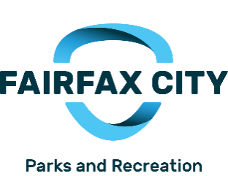

**Upcoming Events:**

.

………………………………………… **Chocolate Lover Festival**

**Chocolate Lovers Festival Committee**- Nothing new to report at this time. Meetings will resume again in September 2022.

………………………………………… Mitzi Taylor [Mitzi.taylor@fairfaxva.gov](mailto:Mitzi.taylor@fairfaxva.gov)

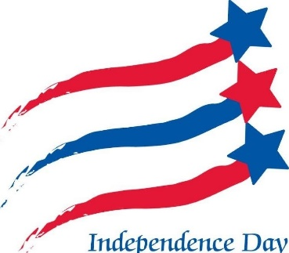

***Independence Day Celebration Committee (IDCC)***.  ***Independence Day Celebration Committee (IDCC***

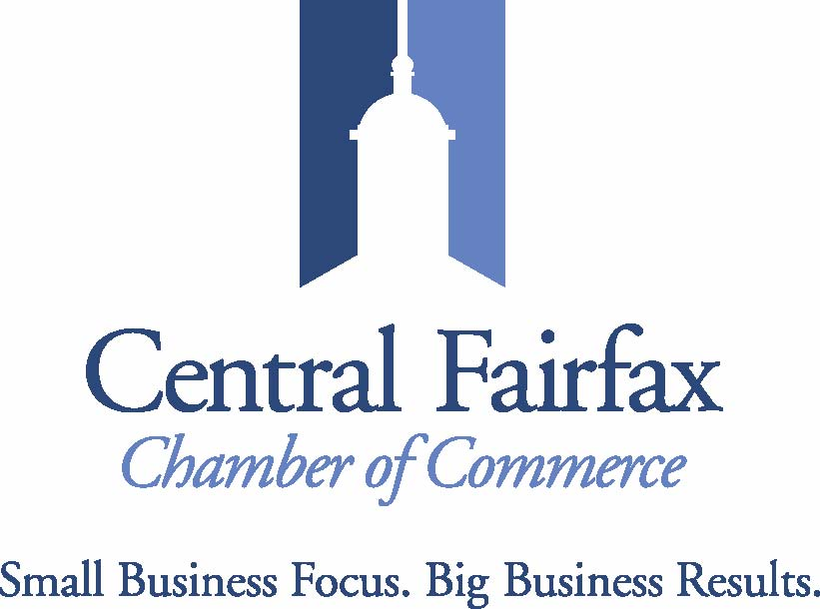

On May 6, the CFCC will be recognized by George Mason with a Jack Wood "Town-Gown" Award in the Partnership Initiative Category. We partnered with many departments at George Mason, the Old Town Fairfax Business Association, and the City of Fairfax to bring the Patriot Perks program to fruition. This is a discount program that businesses offer to members of the "Mason Nation" - students, alumni, faculty/staff, and retirees.

We are very excited to launch our first Veterans Committee programming on Thursday, May 19! Commissioner Daniel Gade of the Virginia Department of Veterans Affairs will serve as our keynote speaker at a Lunch & Learn. There will also be a Resource Fair for businesses and organizations who provide services to veterans and military families.

Our Membership continues to grow and our events for May are varied and relevant! Events are open to the public! Come check us out!!!!

**Jennifer Rose:** [**Jennifer@cfcc.org**](mailto:Jennifer@cfcc.org)

**Civitan Club of Fairfax**

On April 8-9, a hybrid (both virtual and in person) version of the Civitan Chesapeake District spring meeting was held. Hovering in the background was consideration of the pending restructuring of Civitan, which will include the merging of Districts into larger Regions. There are financial and other considerations to be worked out in the few months before the July International Convention of Civitan. How the revamped Regions will operate was an emphasis in April, with several “focus group” developed and tested.

The Board of the Foundation for Children with Intellectual and Developmental Disabilities (FCIDD) also met on 8-9 April. Several proposals for funding from the FCIDD and from sponsoring Civitan Clubs were approved, including a proposal from ServiceSource supported by Fairfax Civitan. There are issues regarding the FCIDD that also are impacted by the pending reorganization of Civitan.

One of the organizations supported by Fairfax Civitan (and by FCIDD) is the Northern Virginia Therapeutic Riding Program (NVTRP). On 21 April, a group of Fairfax Civitans visited the NVTRP facility in Clifton. Much work has been done in the past several years to enlarge and improve the facility, and we were impressed.

The 5 May Fairfax Civitan Club meeting features a presentation from the Alzheimer Association on “Understanding Alzheimer’s and Dementia.” On 7 May, Fairfax Civitan and Arlington Civitan will be running the huge garage sale which is a major fund raiser. On 21 May, a small group of Civitans will be picking up Willcoxon Park, our Fairfax City “Adopt a Spot.”

.

**David Hartmann:**[**chartmann@cox.net**](mailto:chartmann@cox.net)

**Downtown Fairfax Coalition**

**Jim Wyckoff, Jr.: jcwyckoffjr@aol.com**

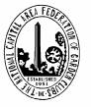 **FAIRFAX FERNS GARDEN CLUB**

Six of the members were docents at the Kitty Pozer Garden on May 26th for the Virginia Garden Club

Historic Tour. Over 105 visitors enjoyed the garden.

The next meeting of the Ferns is May 9th at the City Library. The program will be on “Pollinators” .The main event will be the judging of the yearly Horticultural Project; a succulent dish garden. The blue ribbon winner receives the Silver Tray.

The Garden Club will take a summer break and the next meeting will be in September

**Kathy Hoffman; Hildie Carnie:** [Kathryn.j.hoffman@gmail.com](mailto:Kathryn.j.hoffman@gmail.com); hilcarn31@aol.com

**Fairfax VA Harley**

**Owners Group**

# Fairfax Harley Owners Group

Our 2022 activities are already rolling and we have some terrific new rides planned for the rest of the riding season. There have been some ideal days for riding as well.

During the past month we have had a couple new opportunities to help in the community. One was to help the Fairfax Law Foundation with their Kid’s Run and 5K event on April 24rd at Fairfax Corner to raise funds to support their outreach programs. We provided a Bike “Show & Tell” and were the pace vehicles for the 5K. We also helped the Friends of Fairfax Library with their Book Sale. Our role was to help sort and move boxes of books for the event.

We also were invited to assist the Manassas ISCC with their Installation of Officers at their Annual VOY and Business Appreciation Banquet on April 21st. Was an honor to be there.

Work is progressing on our 22nd annual “Ride of the Patriots” event which will be held on Sunday, May 29th. Our program for this event will be similar to previous years and will feature a short parade, an opening ceremony to honor those in uniform who serve our nation and protect our liberty. This year the Ride of the Patriots will join Rolling To Remember at the RFK Stadium. We encourage you to check out the website at [www.rideofthepatriots.com](http://www.rideofthepatriots.com/). This is a community event that is supported by City, County, Fairfax High School, Captain Pell’s, Patriot Harley-Davidson and Fairfax citizens. Everyone is invited to come see the bikes and help honor those in uniform who put life and limb on the line to defend our families and our nation.. This event attracts riders from across the USA to remember and honor friends and relatives in uniform who have served our nation unselfishly.

If there is an interest by any of the City of Fairfax InterService Club Council member groups in participating, please let me know. Your questions or suggestions will be most welcome.

At the present time the City of Fairfax is planning for the 2022 Independence Day Parade on July 4th. Our FHOG Chapter will participate and help celebrate our nation’s Independence Day.

The Fairfax Harley Owners Group is a diverse and energetic force of over 250 members. The Chapter publishes a monthly newsletter and maintains its own web page at [www.fairfaxhog.com](http://www.fairfaxhog.com)

**Larry** **Larson: larry.d.larson@verizon.net**

**Fairfax City**

**Regional Library**

**City oFairfaxLibrary**

**10360 North Street**

**Fairfax, VA 22030**

703-293-6227 | TTY: 711

Sun.: 1 p.m. - 5 p.m.

Mon. - Thurs.: 10 a.m. - 9 p.m.

Fri.: 10 a.m. - 6 p.m.

Sat.: 10 a.m. – 5 p.m.

The City of Fairfax Regional Library offers a wide range of events for all ages, including children’s programs, ESL Conversation groups and tutoring, technology help, book discussions, genealogy and local history programs, and much more.

<http://www.fairfaxcounty.gov/library/events/>

We had a very successful spring book sale with income of over $17,000 for April.

     We tried a new format of a 4 day sale instead of 3 day sale with dealers only on the first day. It worked beautifully keeping our dealers and patrons separate for the most part with no complaints. Everyone felt the whole process was much calmer than in previous years. Setting up was a very big challenge because we had twice the number of books than in prior sales. Our Kiwanis friends turned out to help with the sale and Larry and his buddy Johnny from the Hogs helped us set up.

     Several exciting things are carrying over into May. First we have money again and can work with the library and community to budget for the rest of the fiscal year and on into September. Second, an estate offered us roughly 300 boxes of books that have been in storage for some years. It is the personal library of someone who had a wide range of interests. Some of the books are damaged, some we can’t sell and will give away at the library. However, many are of value to us and will go into future sales. Transporting them to the library and evaluating them is a daunting task. The third thing is that someone in the community has given us a grant of $5,000 to be used by the library. We are brainstorming with Laura Richards, the librarian, to come up with special idea for this substantial gift.

.**Katie Clary**: [kvclary@mindspring.com](mailto:kvclary@mindspring.com)

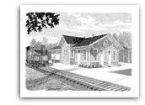

**Friends of**

**Fairfax Station**

**The Northern Virgina NTRAK Club will display and run N Gauge Model Trains at the Fairfax Station Railroad Museum on Sunday May 15, 2022, from 1-4 p.m.  The Station is located at 11200 Fairfax Station Road in Fairfax Station, VA.  Admission: Museum members and ages 4 and under, free; ages 5-12, $3;  ages 13 and older, $5 ($6 special events); seniors and military, active and retired, $4.**

**The Washington DC Metropolitan area LEGO(R) Train Club (WamalTC) will be running LEGO(R) model trains at the Fairfax Station Railroad Museum for a special Mother's Day weekend show, Saturday, May 7 from 12-4 p.m. and Sunday, May 8 from 1-4 p.m. The Museum is located at 11200 Fairfax Station Road in Fairfax Station, VA.  Admission:  Museum members and ages 4 and under, free; ages 5-12, $3; ages 13 and older, $5 ($6 for special events); seniors and military, active and retired, $4.  Mothers admitted free on Mother's Day, Sunday, May 8!**

[**www.fairfax-station.org,**](http://www.fairfax-station.org,/)[**www.facebook.com/FFXSRR,**](http://www.facebook.com/FFXSRR,) **703-425-9225.**

**Pete Conklin:** [**conklinps@aol.com**](mailto:conklinps@aol.com)



HFCI’s activities for 2022 are well underway after two years of limited activity due to the pandemic. We have welcomed two new members to our Board – Catherine Foster and Stephen Hoyle. Hildie Carney resigned from the Board after many years as a stalwart founding member and in recognition of her tremendous contributions to HFCI, the Board enthusiastically voted to make Hildie an Honorary Lifetime Board Member. We hope to keep Hildie involved and active in HFCI for years to come.

Page Johnson is reactivating the FairFacts Newsletter and we expect a new edition to be out soon. Jon Gentile, our new Vice President, is working on reactivating the Walking Tours program.

We are now meeting in person on the second Wednesday night of every month in the Work Room at City Hall. It is a pleasure to be back together, but Zoom was an effective way to keep in touch when virtual meetings were required.

HFCI continues its primary function as the organization that supports the City’s Office of Historic Resources. Susan Gray, the Director of OHR, attends our monthly meetings and reports on all of the wonderful programs and activities that are going on at the Museum and elsewhere.

HFCI’s signature event Taste of the Vine will return on October 7 to the Blenheim Civil War Interpretive Center. Mark your calendars and plan to join us for this important and enjoyable fundraising event.

**John Keith: jkeith@bklawva.com**

**Kiwanis International**

**Kiwanis Club**

**of Fairfax**

We have added 2 more members to our club

              We will be holding elections this month

              We have a nomination for volunteer of the year

**Mariann Gabor****mgabor2010@hotmail.com**

phone’s camera enables a remote assistant (a real person) help the[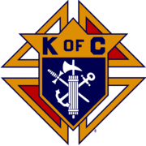](http://en.wikipedia.org/wiki/Image:Kofc.gif)

**Knights of Columbus**

**Father Diamond Council 6292**

The Council holds business meetings on the 2nd and 4th Tuesday’s of the month at 8 PM in Providence Hall at St Leo the Great Catholic Church. Web site**:** [**WWW.6292.kofc.com**](http://WWW.6292.kofc.com)**.** All meetings currently are hybrid (In person and virtual).

**K**ovar collections resulted in around $10,000 for this charity.

# May Activities:

- May 9 – Bingo at the Fairfax Nursing Home

- May 14 – Antique Car Show concession

- May 15 _ Family Breakfast after 7:30 AM and 9 AM Masses

- May 24 – Officer Elections

**Albert Leightley:** [**Leightley8@verizon.net**](mailto:Leightley8@verizon.net)



Our speaker on April 5th was Ms Annette Carr, who is vision impaired. She told us about “AIRA.” Artificial Remote Intelligence Assistance is a nifty smart-phone app (paid service) providing a valuable resource for vision impaired persons. In short, the holder of the phone with navigation, locating objects, understanding surroundings, etc.

Audrey Nagle, an 8th grader at Rocky Run Middle School, received an award for the winning "Peace Poster" this year.  For 34-years, Lons Clubs around the world have held peace poster contests. We also awarded Ms. Linda Ledbetter (Art Teacher at Rocky Run) a $100 gift card to purchase student art supplies to supplement standard supplies for students.

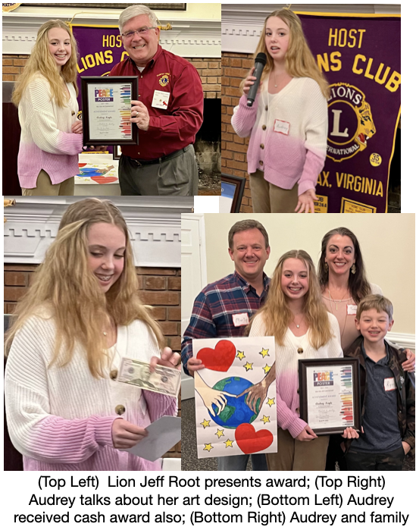

Upcoming:

May 7 - “Roadkill” Trash Cleanup, Pickett Road

May 15 - Fairfax Lions 72nd anniversary of founding ("Charter Night”), at Chantilly County Club

June 4 - Fairfax Lions Tour DC Temple (The Church of Jesus Christ of Latter-day Saints).  We will probably charter a bus from Fairfax to the Temple; we may have room for guests.  If you are interested (there will be a charge for bus rental) send email to:  [info@fairfaxlions.org](mailto:info@fairfaxlions.org)

**Gordon Tillery:** [**tilleryg@gmail.com**](mailto:tilleryg@gmail.com)



**Centreville Moose Lodge #2168**

This month the Lodge is hosting the Life Line Health Screening on May 9. Through our food donation collection program, we are providing canned and dried to the Robinson House half-way center, the Girl Scouts Blessing box in Van Dyke Park, the Lamb Center and other organizations in Fairfax. Our used clothing donations are provided to the INOVA Thrift Store and the Lamb Center.

We are looking forward to having our float in the City of Fairfax 4th of July Parade this year featuring the Charlie Brown band and Tommy Moose.

We continue to offer free Texas-Hold-Em games on Tuesday evenings (7PM) and Sunday afternoons (2PM), Bingo every Wednesday evening for 6:15 to 9:30PM, Taco Thursdays from 4:30-8PM and Friday Night dinners from 5:30-8PM.

**Herb Zimmerman herb2777@yahoo.com**



CENTRAL FAIRFAX OPTIMIST CLUB

The Optimist Club held their first 'in-person' meeting of the year at the Elks Lodge in Fairfax.  It was successful and really nice to see everyone!

We celebrated our outstanding Oratorical Contest Winners, Ryan Augustine, Elaina Jacob and Spriha Mohanty. The theme of the speeches was "Staying Optimistic in Challenging Times."  It was a treat to hear their speeches by these incredible young peoiple and to recognize their achievements in public speaking.  Ryan and Elaina will go on to the District Contest.

Our Club is examining new creative ways to fund raise.

The Optimist Club of Central Fairfax elected the new board of officers for 2022-2023.

**Officers:**

President           Claudia Morcelo

Vice President   Sharon DeBragga

Vice President   Bruce Lauther

Secretary         Ann Grabowski

Treasurer         Sue Bond

**Directors**

Toni Donovan

Kim Moden

Michele Hanson

Fred Kaiser

Bob Devery

Dee Rushforth

**Trinket Troy**  tearrific@aol.com



**Doug Church** douglaschurchjr@gmail.com



**Salvation Army**

**Women’s Auxiliary**

The Salvation Army Auxiliary of Fairfax continues with the 2022 Fund Raising Project- a Donation Campaign.  May plans include installation of officers for 2022-2023, as well as attendance at the Fairfax Corps Volunteer Appreciation Luncheon on Thursday, May 12.  The Auxiliary will drop off cakes at the Salvation Army Adult Rehabilitation Center in Annandale to help celebrate the ARC client's birthdays. This has been a tradition carried on by the Auxiliary for many years. The next cake donation is in May.The Corps will be having a Yard Sale on May 21 - More information to follow.

Major Jean Wilson announced that she and Major Donny Wilson will be transferred to Hagerstwon, MD in June. There will be new officers transferring in at the end of June.

**Connie Lauther:** [**lauthers2relo4u@cox.net**](mailto:lauthers2relo4u@cox.net)



ServiceSource Virginia had an Amazing April!

ServiceSource has received the Platinum seal of transparency from Candid for all five regional offices for having best practices within our industry.

ServiceSource was awarded its first grant of $91,000 through the CareFirst Economic Inclusion funding opportunity. This grant program is focused on health inequities by addressing the Social Determinants of Health, which include economic stability. With this funding, ServiceSource will launch a new Information Technology (IT) Training Pilot program, serving 15 individuals facing barriers to employment. ServiceSource will provide technical skills and essential workplace skills training to those served.

ServiceSource Virginia’s Wellness Center for Older Adults (WCOA) was recognized by the Fairfax County Board of Supervisors during the monthly board meeting. The WCOA is being touted as a “first of its kind” in the county.

The Wellness Center for Older Adults (WCOA) had their soft opening on March 14th, 2022. Since its opening, staff have welcomed several community members 50+ and five new participants to the location's Long-Term Community Integration Services (LTCIS) program. All are partaking in activities such as creative art sessions, mental muscle games and walking club. In addition, community partners are hosting weekly events in the space, such as free blood pressure screenings.

For this project, ServiceSource Virginia is working with Fairfax County’s Neighborhood and Community Services (NCS) to serve community members 50+ and those with disabilities. The WCOA offers programs, presentations, and services to assist the needs of community members, both virtually and in-person. Program goals include fostering positive health choices, increasing social connections, creating meaningful activities, achieving therapeutic benefits, and empowering individuals to engage in health education. ServiceSource Virginia serves as the anchor organization for the WCOA, inviting community partners into the program to bring services to support members in achieving their goals.

An official ribbon cutting ceremony for the WCOA will be held on Thursday, May 19. To watch, tune into Channel 1016 (Cox), Channel 16 (Verizon/Comcast) or stream live at: [**www.fairfaxcounty.gov/cableconsumer/channel-16/stream**](http://www.fairfaxcounty.gov/cableconsumer/channel-16/stream).

Please feel free to also check out our program on our webpage: [www.servicesource.org/virginia-wcoa](http://www.servicesource.org/virginia-wcoa)

**Sagan Brummett**

saganbrummett@**servicesource.org**



Join us on **Sunday, May 29th** at **MOD Pizza in Reston** (Plaza America Location) - 20% of all online and in-store fundraiser sales will go toward our cause! [Present this flyer](https://default.salsalabs.org/T76e4a2e5-7679-442c-b6d4-e92c3ab32553/4ea1f5ea-fb34-466a-b589-8956f02efc47), mention 'Shelter House' at checkout or use coupon code **MODF7004** when ordering online.

**Joe Meyer:** [**joe.meyer@shelterhouse.org**](mailto:joe.meyer@shelterhouse.org)



**Shepherd Center Fairfax Burke (SCFB)**

.

**Shepherd Center Fairfax Burke (SCFB)** SCFB is dedicated to helping older adults continue to live independently, and to providing enrichment and social networking

opportunities that keep life exciting and rewarding. Programs include Accompanied Medical Transportation and Companion Shopping (for older people who are no longer able to drive), Friendly Callers/ Visitors (for people who are mostly homebound), Caregivers Support Group (for those who have loved ones with dementia), low-cost exercise and yoga classes (to promote strength, balance and flexibility), and Lunch N’ Life, Adventures in Learning, and Wednesday at the Movies which all provide mental stimulation and socialization opportunities. For SCFB significant future and below activities see our web site [www.scfbva.org](http://www.scfbva.org).

DUE TO THE COVID RESTRICTIONS THE ONLY PROGRAMS CURRENTLY OPERATING ARE MEDICAL AND SHOPPING TRANSPORTATION IN BOTH FAIRFAX BURKE AND SOUTH COUNTY, CHAIR YOGA AND BOOK CLUB VIA ZOOM, and FRIENDLY CALLER . AIL, LUNCH N LIFE, AND MOVIES ARE SUSPENDED UNTIL FURTHER NOTICE.

But Shepherd Center is still active,

1. Transportation Program –had 307 Medical and Shopping Drives by SCFB drivers during month.
2. Chair Yoga – SCFB Exercise Program conducted via Zoom, 3 times a week during the last month and average 62 participants per session.
3. Friendly Caller – made 260 contacts for the month.
4. Friendly Visitor –30 during the month.
5. Book Club – 1 Event with 17 participants.
6. Held Volunteer Appreciation event on April 20th.

Volunteer Drivers and ride schedulers are critically needed. Please pass to your organizations. They can contact me at 703-273-2089 or [Leightley8@verizon.net](mailto:Leightley8@verizon.net) if interested.

**Albert Leightley:** [***Leightley8@verizon.net***](mailto:Leightley8@verizon.net)

**Connie Lauther**

***Soroptimist International of Fairfax County***

Trying to figure out if we can survive into our 78th year.

**Cathy Kelleher: dandckelleher@cox.net­­­­­­­­­­­­­­­­­­­­­­­­­­­­­­­­­­­­­­­­­­­­­­­­­­­­­­­­­­­­**



**Woman’s Club of Fairfax**

.

.

Not a lot going on this month.  The biggest accomplishment is that the Scholarship Committee is reviewing  applications and will make the final selection this week.

Our club's application for Rock the Block was accepted for August.

Planning for fashion show continues.

We will be inducting two new members at our upcoming meeting.

**Suzanne Grimsley: suzanne.grimsley@yahoo.com**



**Service** - Continued support of the DVAC through monthly gift cards for stocking the grocery pantry. Two members had a tour of the DVAC facility when they delivered the gift cards in April.

**Advocacy** – Continued support for elimination of child marriage.

Continued support of the elimination of the practice of female genital mutilation through individual and Zonta International USA Caucus support of the bipartisan Empower Our Girls Act (H.R. 829) This act adds female genital mutilation (FGM) to the seven assistance grant programs in the Violence Against Women Act. It would also require the FBI to classify FGM as a Part II crime in the Uniform Crime Reports. Anyone can notify their congressman or congresswomen asking them to support this bill.

Continued support for CEDAW. With the passing of the Fairfax CEDAW resolution by the Fairfax County Board, the working Group for CEDAW is convening on May 25th at 7:30 pm on Zoom to begin to work on a strategy to hold our County supervisors accountable vis-à-vis the resolution. If you or others in your organization wish to participate, let me know and I will send the Zoom meeting link when I receive it.

**Club News –** In March the club elected new officers and installed them at our April 25th meeting. Our new President – Mary Rainey. I will send her address, phone and e-mail to Kathy Hoffman for the ISCC roster.

With the pandemic, several of our regular fundraising activities were cancelled. As more of the annual activities like Rock the Block start up again, the Zonta Club of Fairfax will again participate. The club continues our on-line fundraisers with Abby Candles and Boon Supply year-round.

The club has re-established the NOVA Community College Scholarship. In our 2022-2023 budget the club approved an increase in the amount of the two GMU scholarships from $1500 each to $2500.

The Zonta International Convention, held every two years, is scheduled for June 25-28 in Hamburg, Germany. A couple of club members President Mary Rainey and member Judith Johnston will attend in person. Bobbee Cardillo, our District 4 Director, is a candidate for Zonta International Director.

**Blanche Anderson:** [blanchewa@msn.com](mailto:blanchewa@msn.com)